Quick Tutorial

Observation App
(Released for internal testing)
Version : 0.0.1

Dated : 29-June-2021
Author : Bhabesh Bhabani Mukhopadhyay
Lead Engineer
Division Of Biotechnology And Plant Health

Ås H7
Høgskoleveien 7,
1433 Ås, Norway





Change Request

Title | Date | Author | Subject | Version
Creation Date | 29-June-2021 | Bhabesh | Initial Draft | 0.0.1

Table of Contents
About 4
Features 4
Availability 4
Platform 4
Access procedure 5
Access for Google Play 5
Install from Google Play Store 6
Operation Procedure 9
Welcome Screen 9
Login Screen 9
Menu Items 10
About 10
Observation list 11
New Observation (Empty crops) 11
Crop Category List 12
Crop Category 12
Create Observation 13
Crop 14
Pest 15
Observation Date 16
Observation Map 17
Quantification 18
Save 18
New Local Observations 19
Sync (Synchronize) 20
Existing Observation 21
Capturing Images 22
Save/Delete Image 23
Updated Local Observations 24
Server update 25

About
Mobile application for Observation App addresses wide range of audience. From adviser, researcher, farmer to any one can be part of this program, who can contribute related observation based on plant health and has valid user account in NIBIO’s VIPS Logic system.

Features
Some key features of the app described below for your kind reference :
1. Observation collected from this mobile app can be well synchronized with VIPS Logic server and vice versa.
2. This app can easily record the location based on user’s permission and choice.
3. Observation images can also be shared to VIPS Logic system.
4. Existing Point of interest can be well visible, editable through this app. User can even create their own point of interest of their chosen field/farm for easy of reference.

Availability
Currently the app is available for internal testing. Therefore only selected registered users are allowed for this internal testing program. We are now in alpha phase of testing. We are expecting some issues to be reported by the users and happy to address those for phased released and making the application more usable.

Platform
At this phase the app is only available in Google Play for Android users. We are positive to release for IOS (I-Phone) users in near future.

Access procedure

Access for Google Play
Invited user’s might receive an link to get the app from google play.
The link might be : https://play.google.com/apps/internaltest/4700478055302598030
As per present requirement, users need to register their google account to the VIPS Team to access the app.
You are requested to click the link from your mobile (Android) only and not from desktop computer.
Upon clicking the link shared in invitation email you will find the following screen :
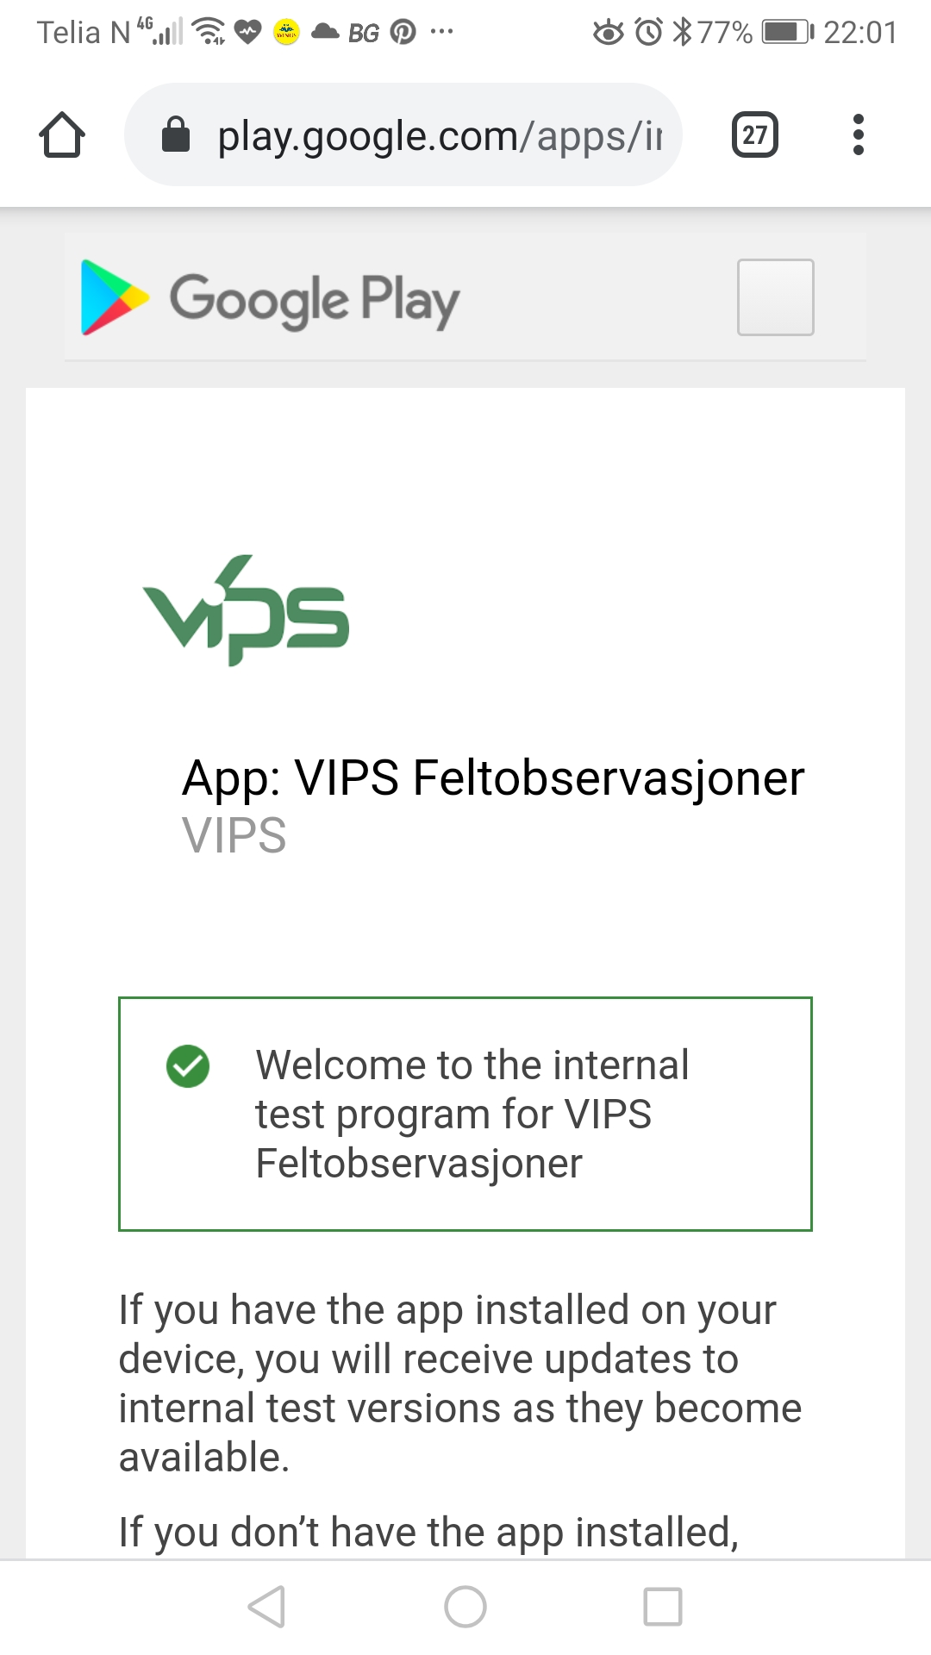
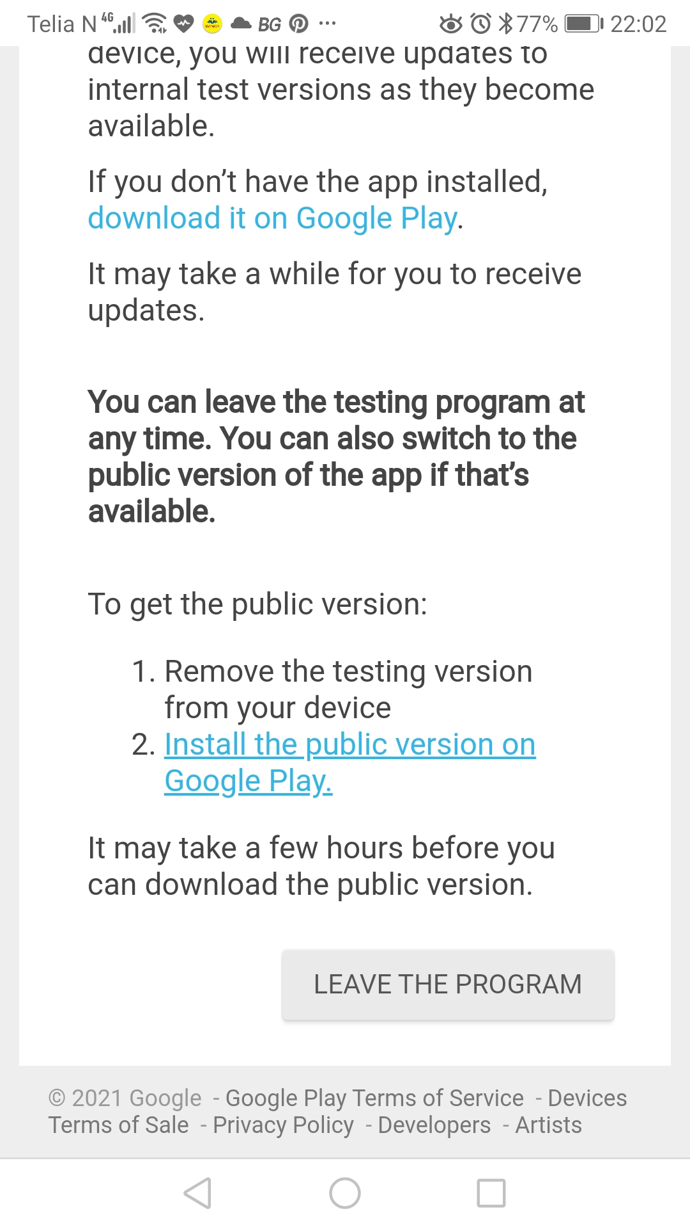
1
Please scroll the screen and you will find link to connect to google play store.
Please click download it on Google Play link .
2

Install from Google Play Store
Now after click above mentioned link you should be in google play store
You screen should look like following :
Please hold your breath. Don’t install at this time
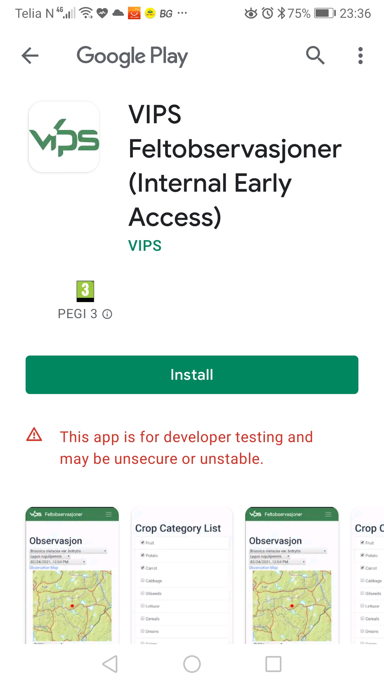
1

As we are constantly updating this app. Therefore the following section will be helpful to understand the correct version to be used in your mobile.

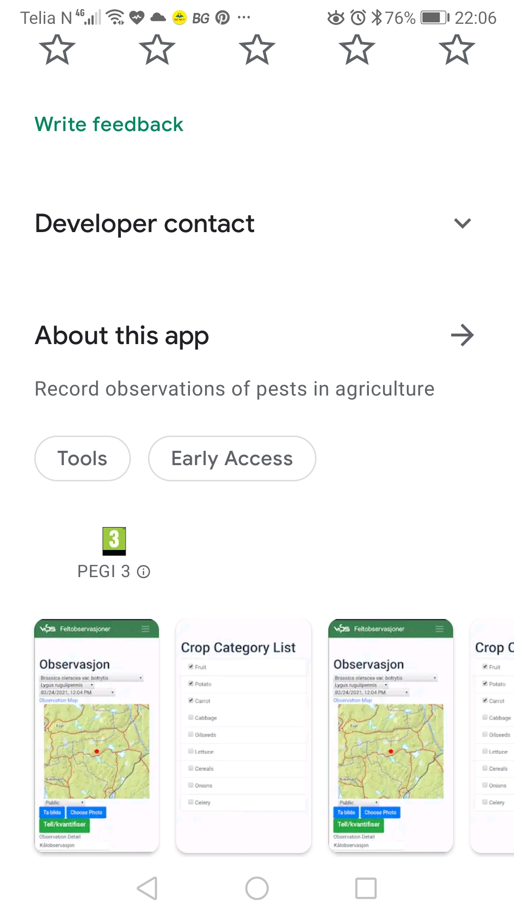
Now please scroll a little and you will find some more feature :
Click this link to know more.
Please click About this app link and go to the next section.
You will find some useful information.
2
Now this About page is little interesting.
Any information for new version might
published here from development team
In this What’s new section
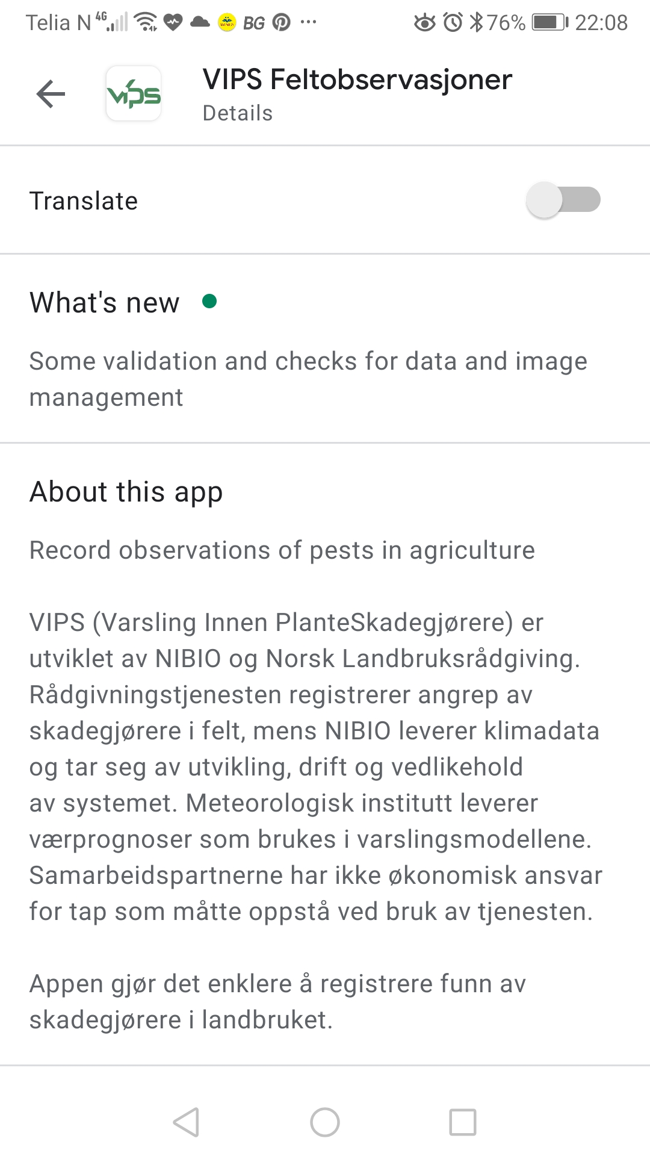

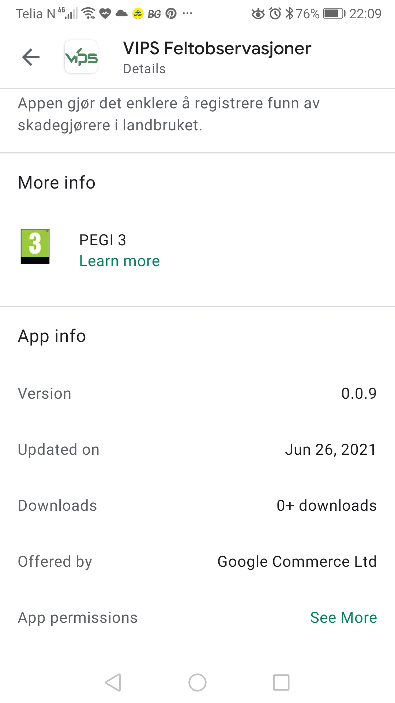
Now scroll a little and you will find the version information.
Here you will find version and update date.
This version information is very important to know
whether you are using our recommendation on latest version.
If you need to install latest recommendation version, need to compare the version mentioned here.

It’s observed, that based on your installation, it might show previous version. In that case you need to uninstall the app. Close this installation page and come back again. You will find the correct version to install.

Once your data synchronized to server, will not lost.
Now it’s time to install. Please go back to earlier screen and install.

Please Install the App now

Wish you good luck !!

Next page onward will explain operation procedure of the app.

Operation Procedure
This and following sections will explain operation procedure of the app. It’s easy. It’s advisable to follow the guidelines to overcome any issues.

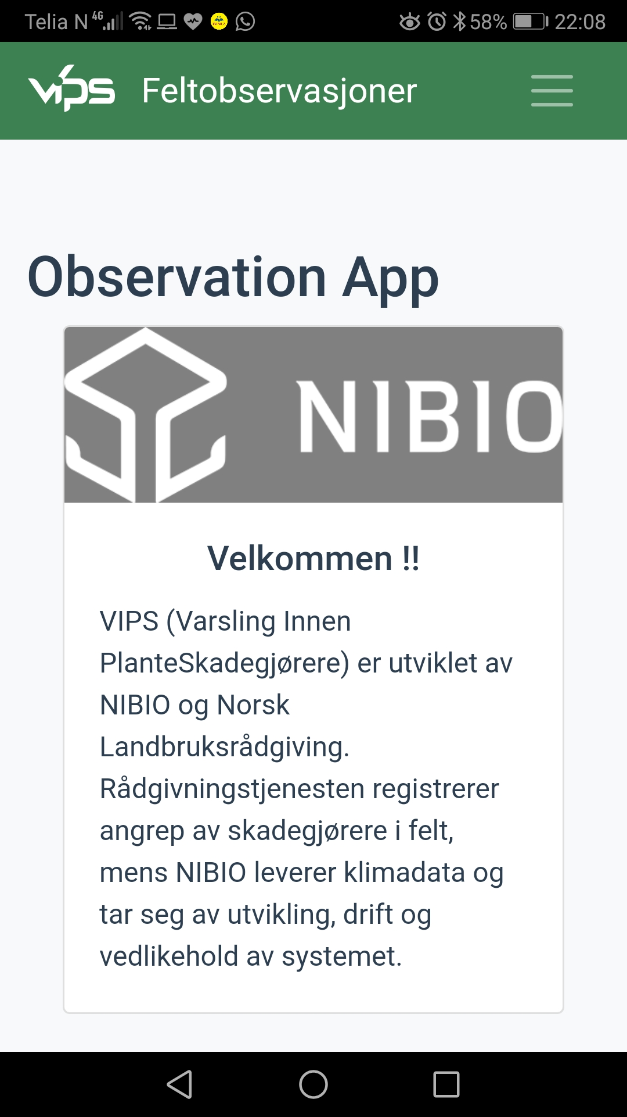
Welcome Screen
Menu
VIPS Logo
This is the App welcome screen with VIPS logo on top left and a hamburger menu on right

You need to click on the menu to get login screen.

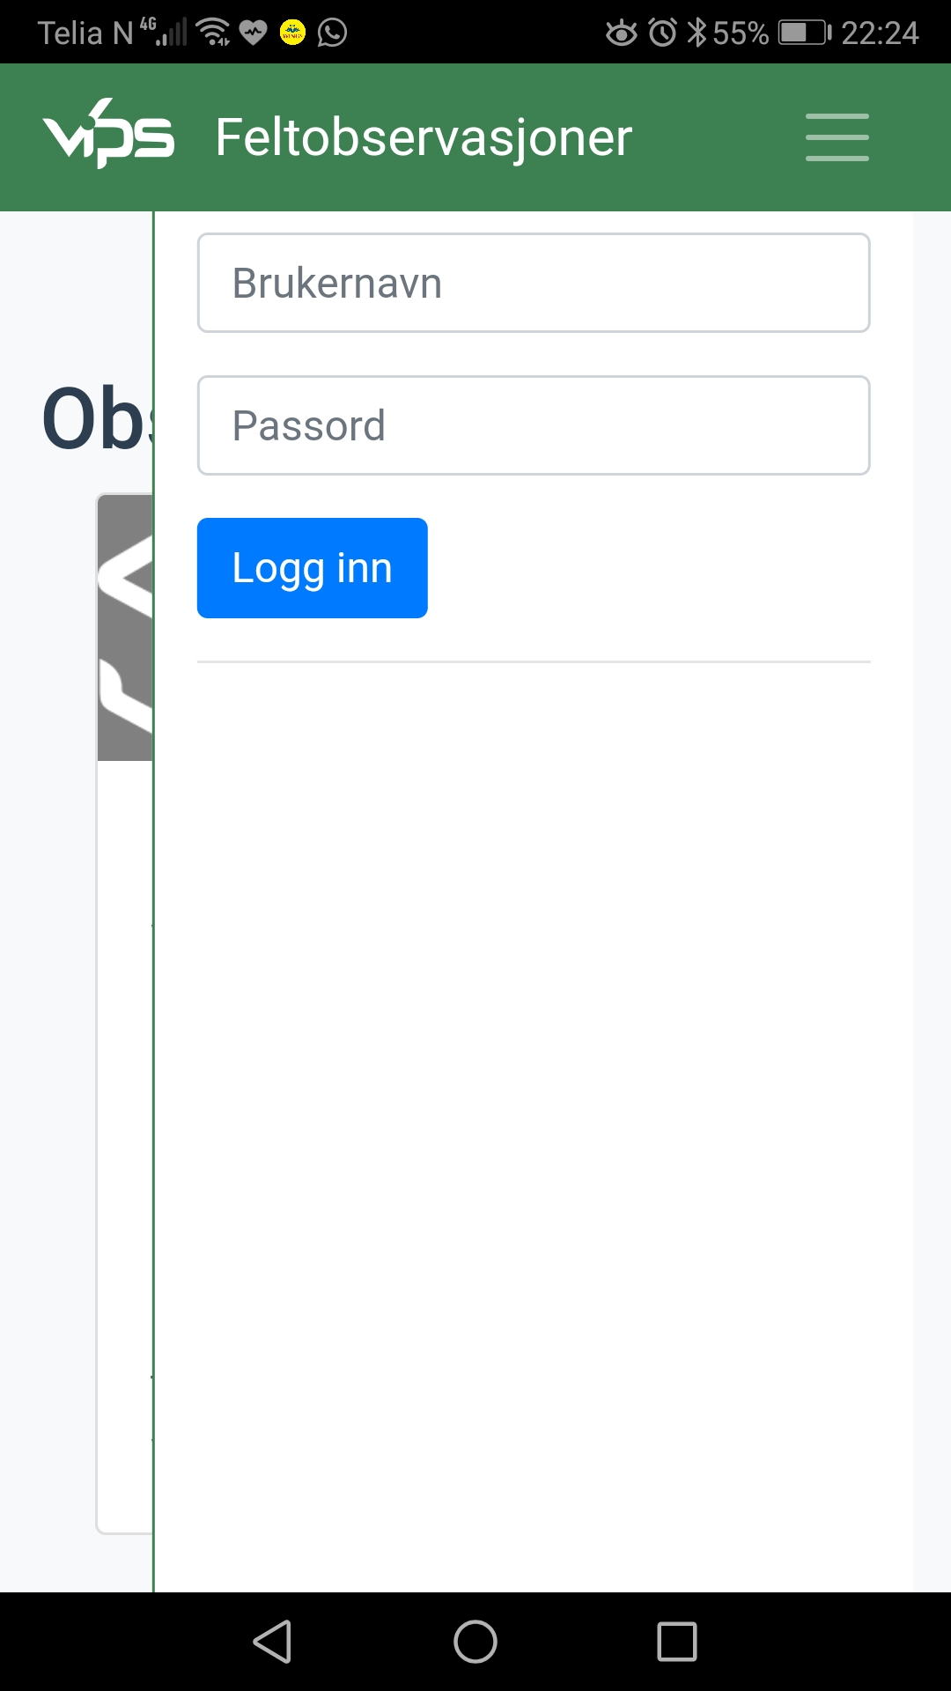
Image : s_001

Login Screen
VIPS Observation APP is a login based system. It will use the same login as of with your VIPS Logic.

For Internal testing you should use your VIPS Logic test login (http://logic.testvips.nibio.no) and not the production login.

I would like to request you to use your VIPS Logic test user login id and password to access this mobile application.

Image : s_002

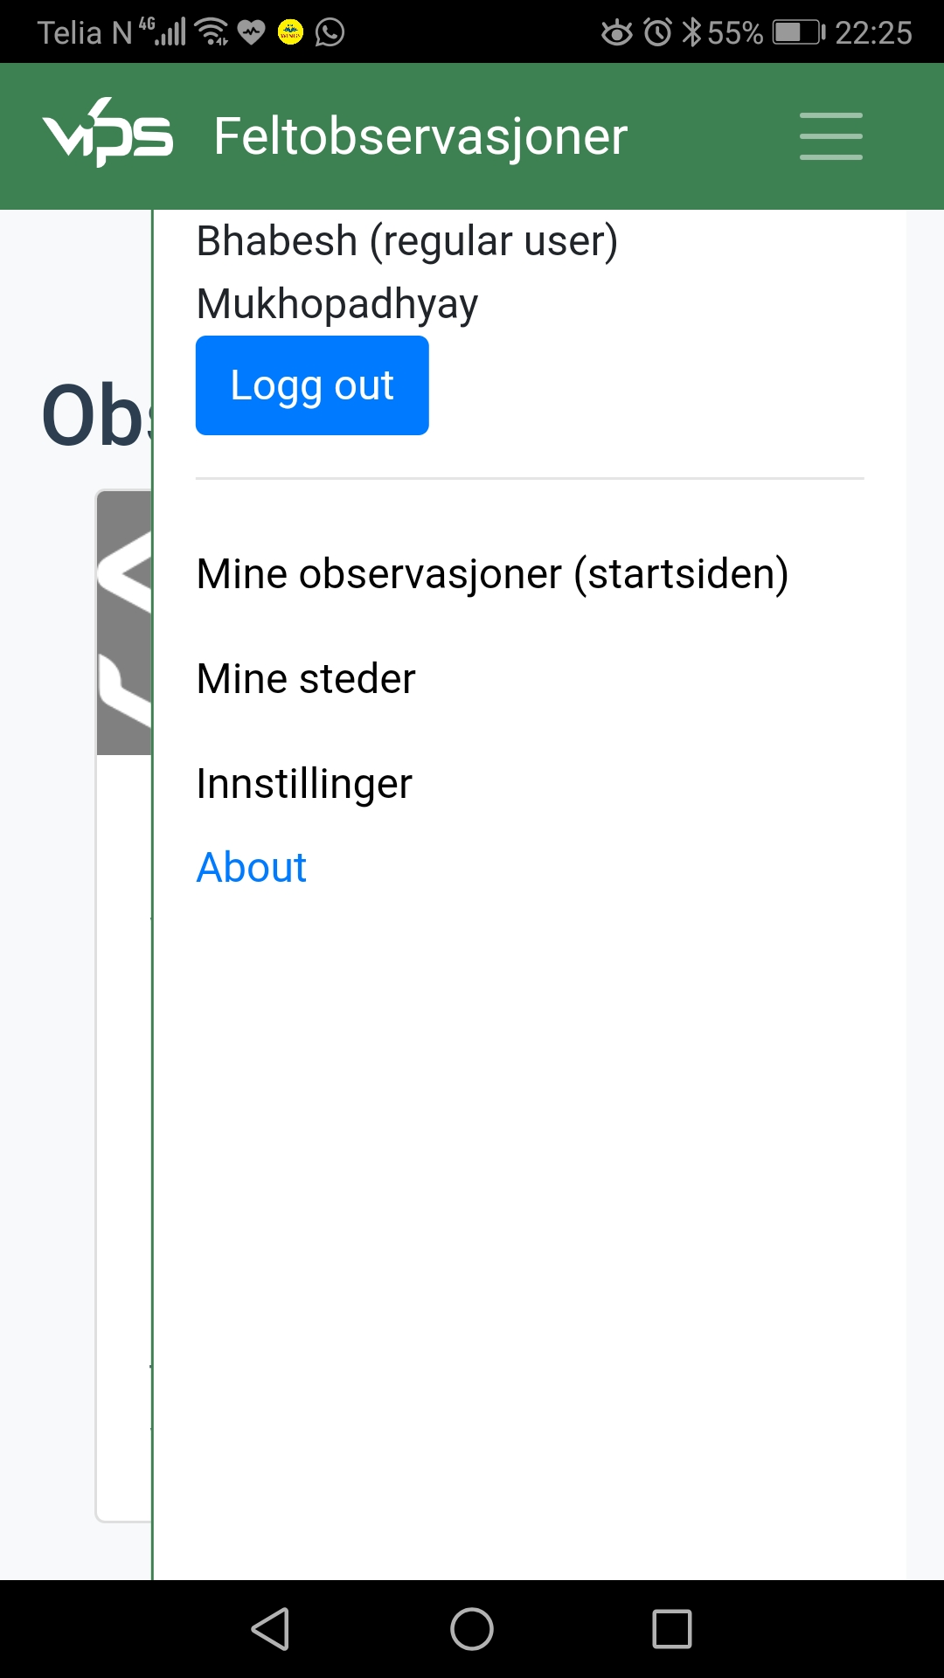
Menu Items
User Name
Menu items are available only after successful login.

Following components are available after successful login.

1. Top part shows user name
2. Log out button
3. List of Observations
(Here you will create or pull
observations from VIPS Logic)
4. Places list (List of Point of Interest)
5. Settings
(Here you can set crop category and
synchronization with VIPS Logic
Server)
6. About
(Here you can see app’s version
number)

1
Log out button
2

Observation List
3
Places List
4

Settings
5
About
6

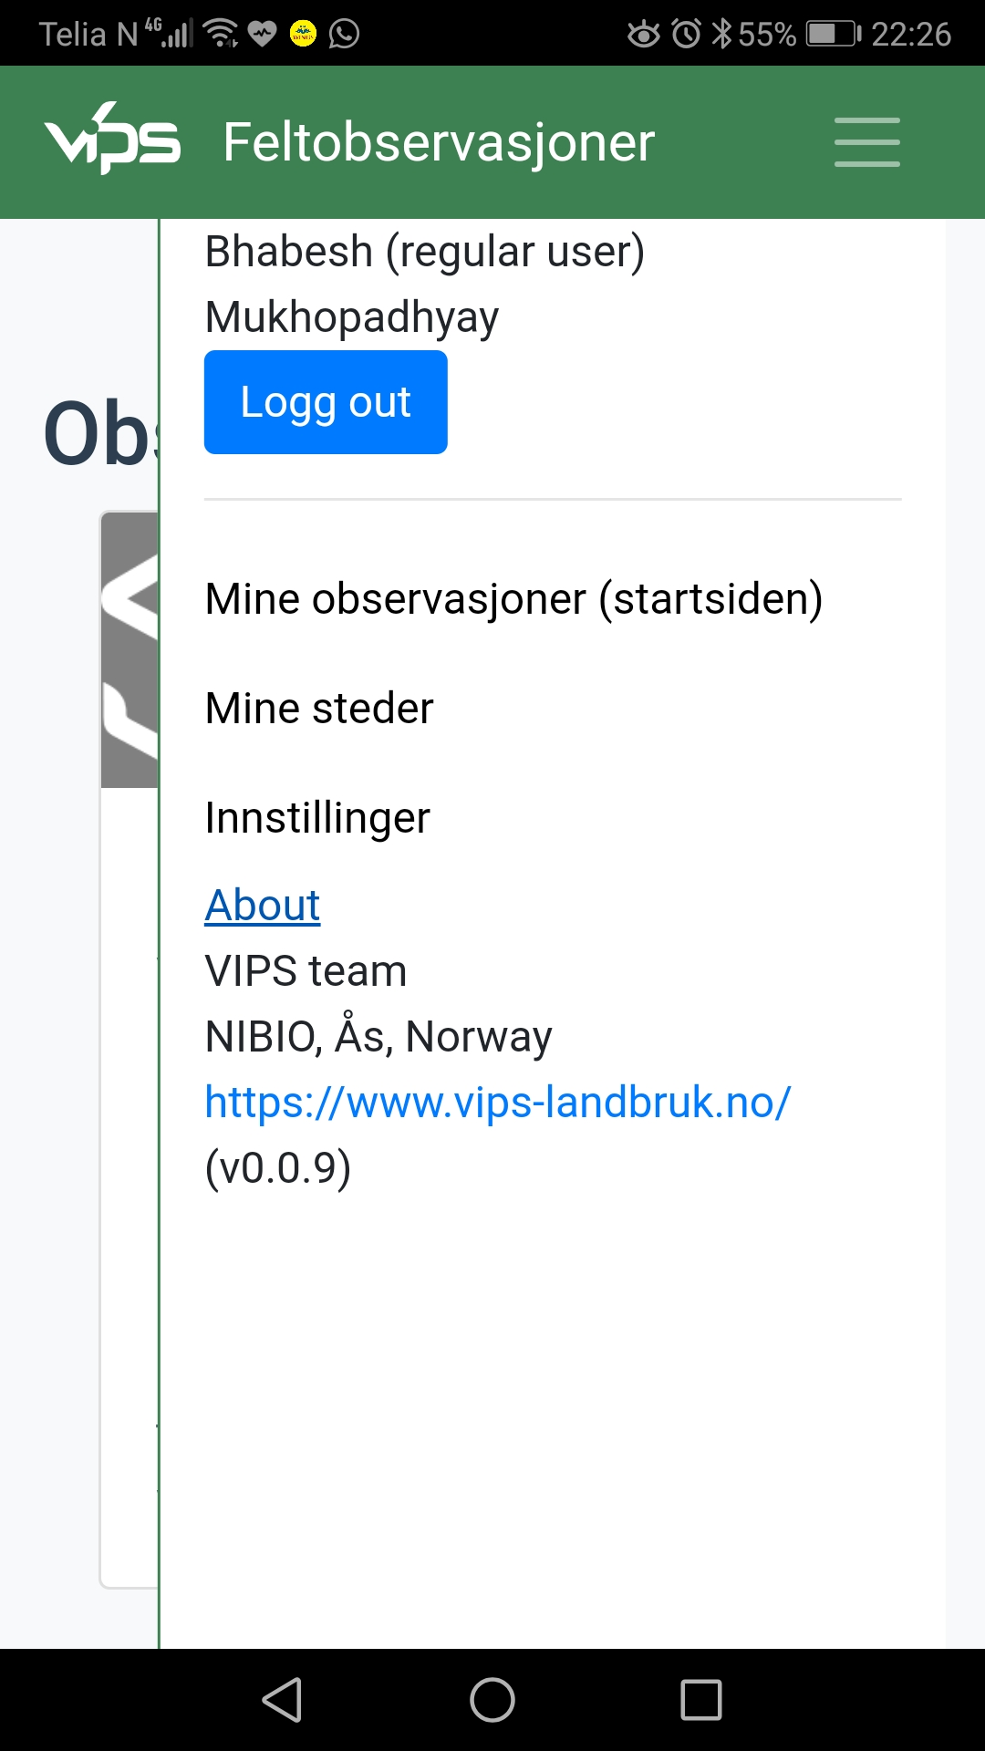
About
About section shows some information about VIPS Team and version number.

Version number is very important to understand whether we are using the latest system or the app need to be updated to get the correct one.

Version Number

Observation list
2
Observation List
Your list of Observations can be obtained by clicking either of two places.

1. Within the menu option
Named : Mine Observajoner (startsiden)

2. On the top after the VIPS logo
named : Feltobservasjoner
1
Add new
Observation
Your observations
will be here

New Observation (Empty crops)
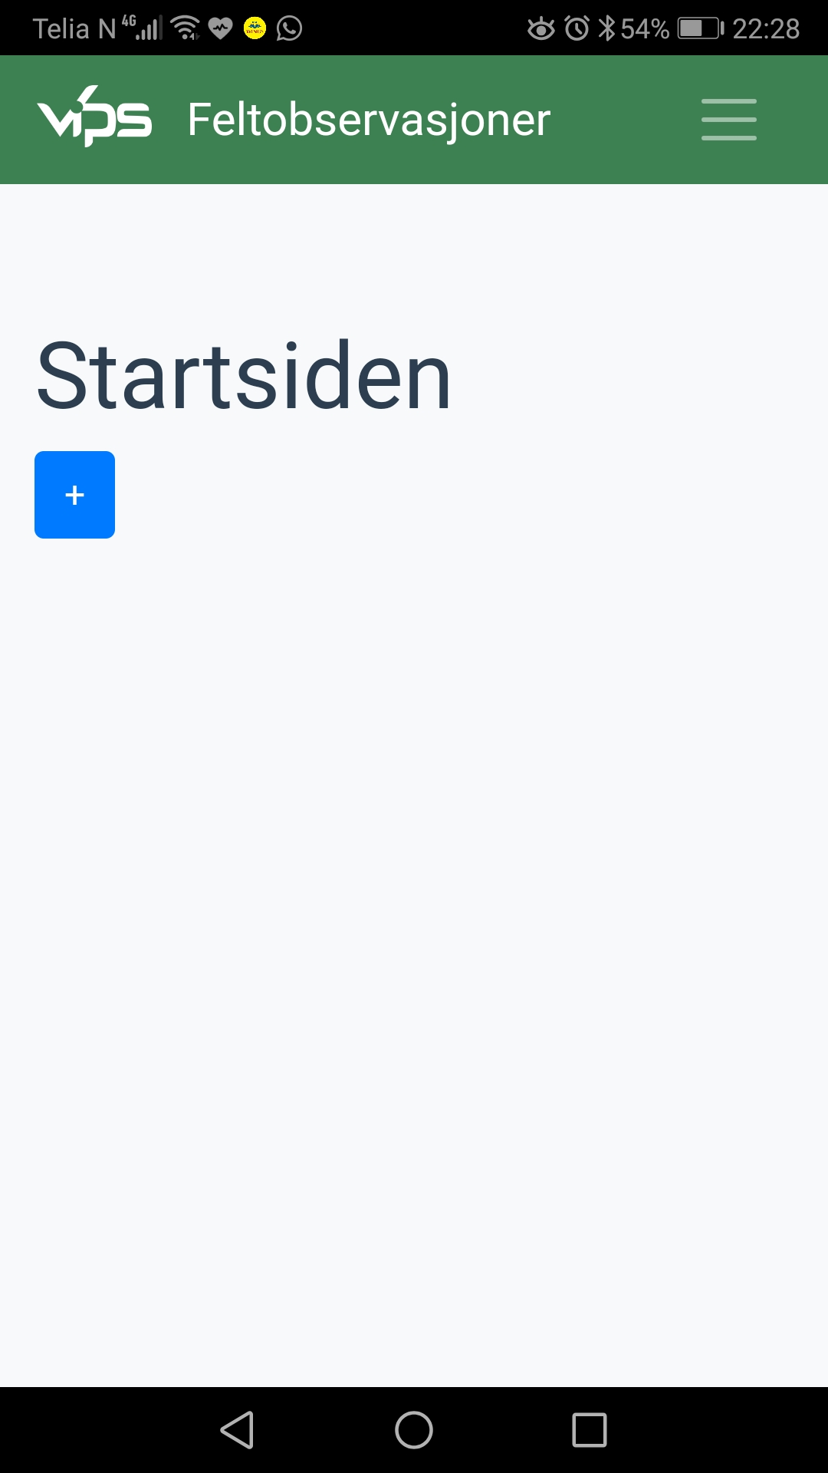
Your all existing observations can be viewed here.
You can add, edit and remove your own observations.

Top of your observation list, there is option to add new observation.

At the very beginning you might find no observations. That’s OK, if you don’t have any.

Here you will find one blue plus ( + ) sign. Clicking this sign will allow you to add new observation.

I would like to request you to click to add a new observation.

Crop Category List

It’s possible that if you didn’t select Crop category for your observation/s then you might face this screen at the time of creation new observation .

This Crop Category List screen can also be achieved by clinking menu -> Settings (Innstillinger) -> crop category
(screen images given below for reference)

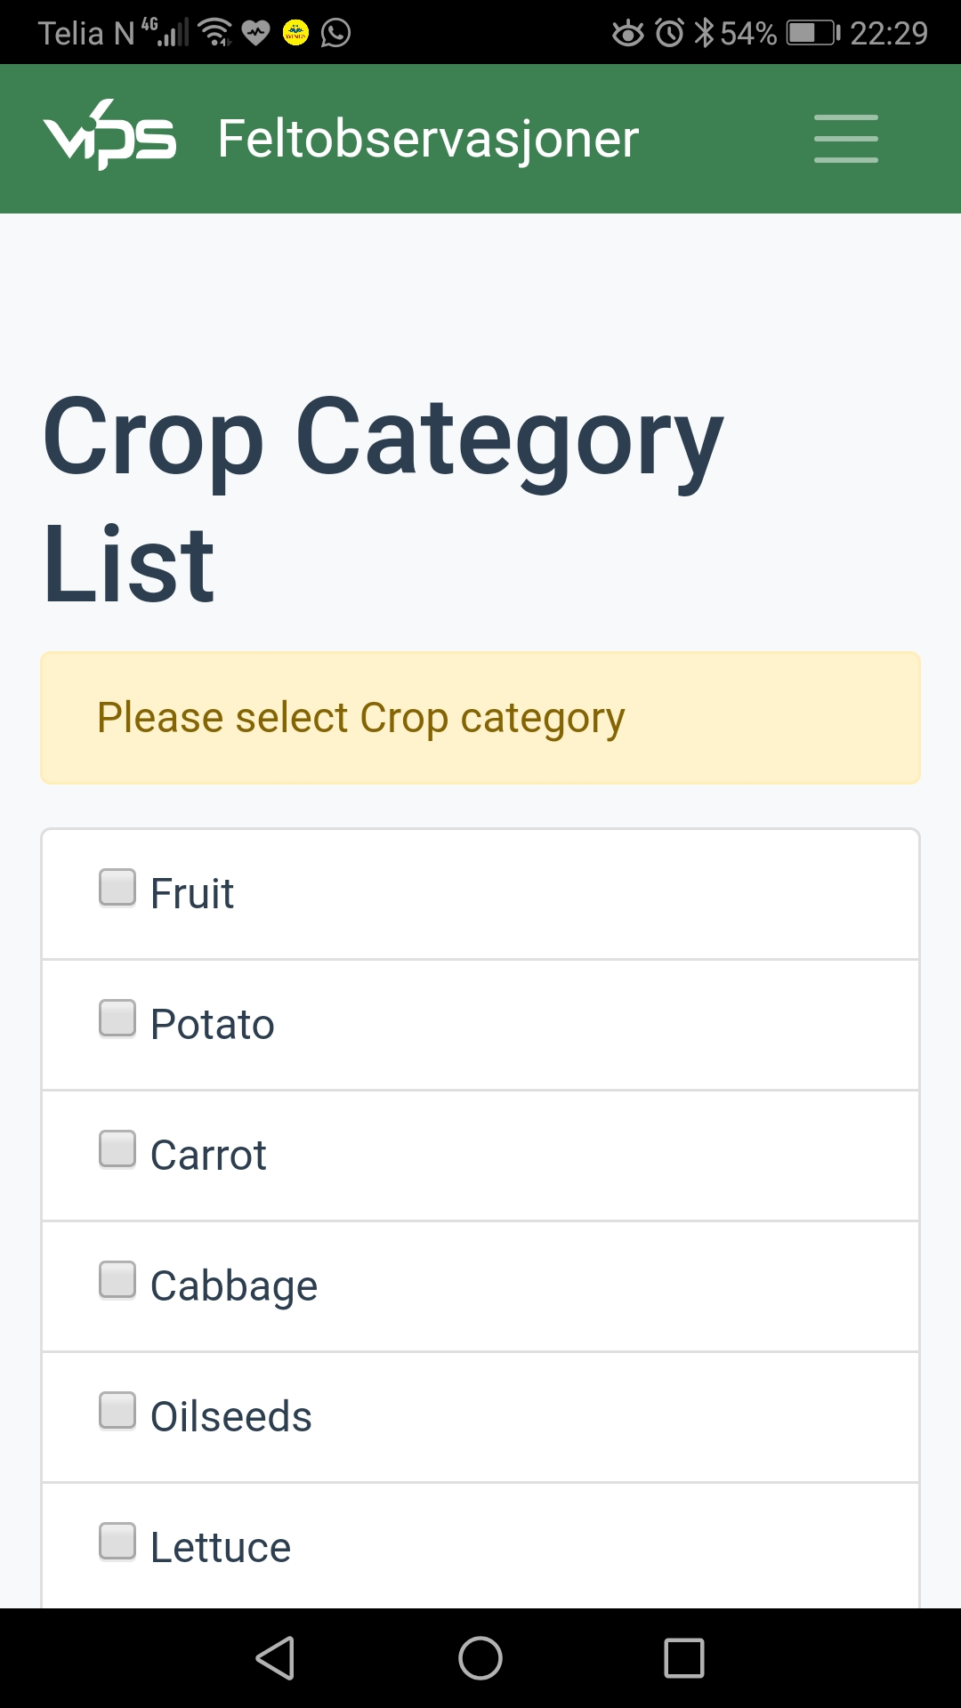

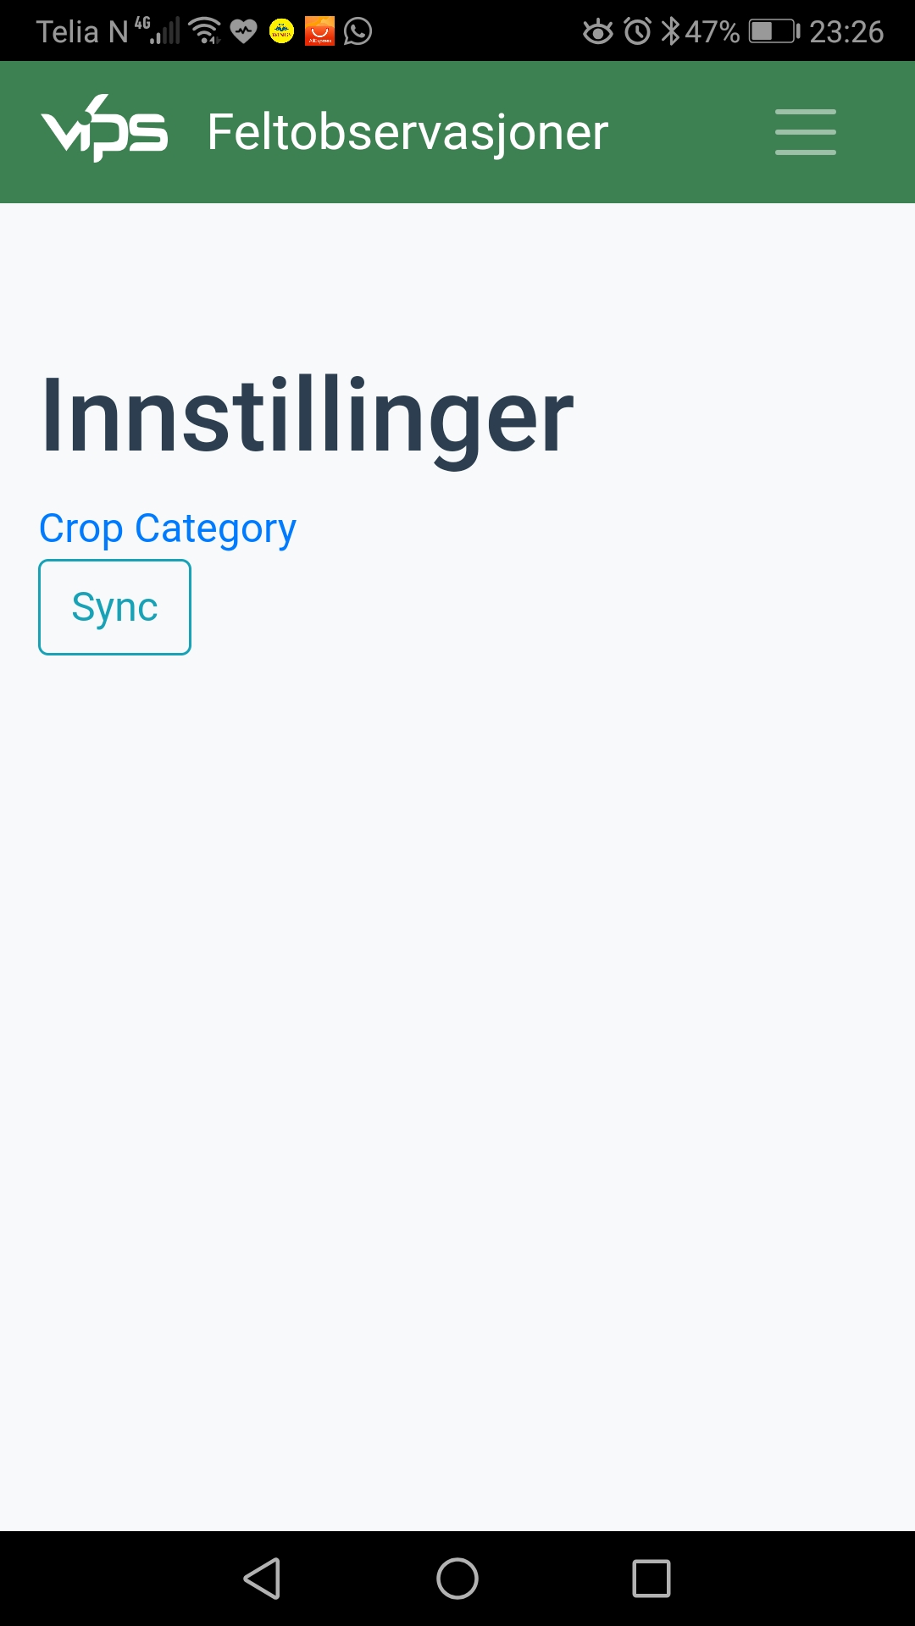

2

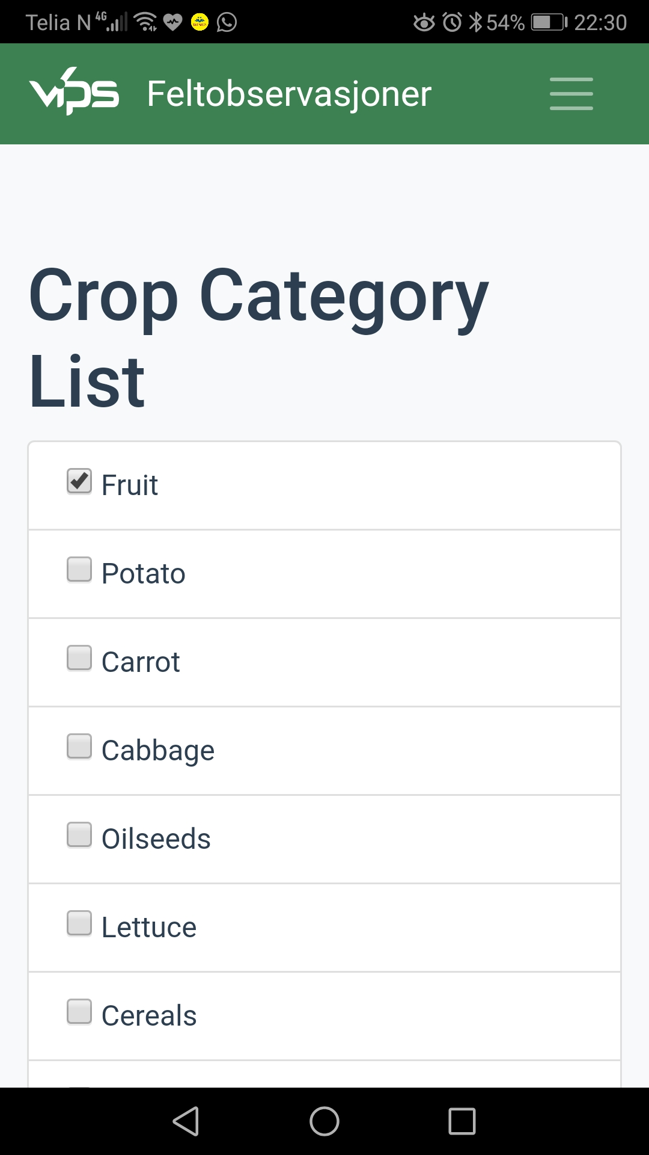
Crop Category
Back to
Observation List
In crop category List, you can select one or multiple category. Even you can select all the crop categories too.

It’s advisable to select only the category required to shorten the list of crops to choose at some other point of time.

One interesting thing is, if your existing observation/s does not have the selected crop category, still they will show the crop category the has and will work perfectly.

I would like you to click
1. One or more crop category.
(Here I select Fruit)
2. Click Observation List Feltobservasjoner

1
Select
Crop Category

Create Observation
Add new
Observation

Now you are back to Observation List again.

To create or add a new observation please click
one blue plus ( + ) sign, which will allow you to add new observation.

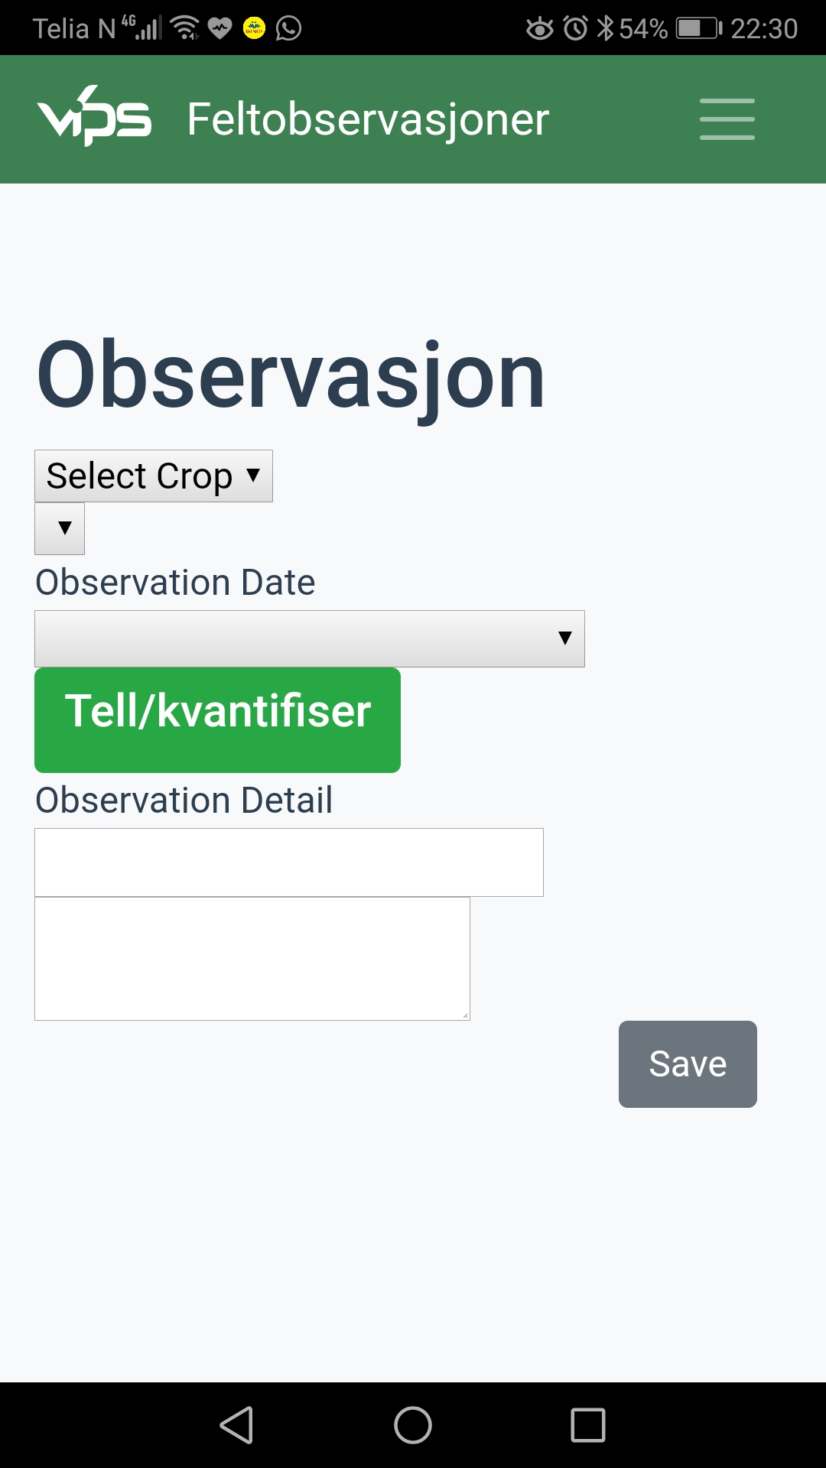
WELCOME !!
At this stage, user can start using selecting crop.
Pest can not be selected without select the Crop.

Click on Select Crop drop down
Select Crop
Select Pest.
Only available
after select Crop

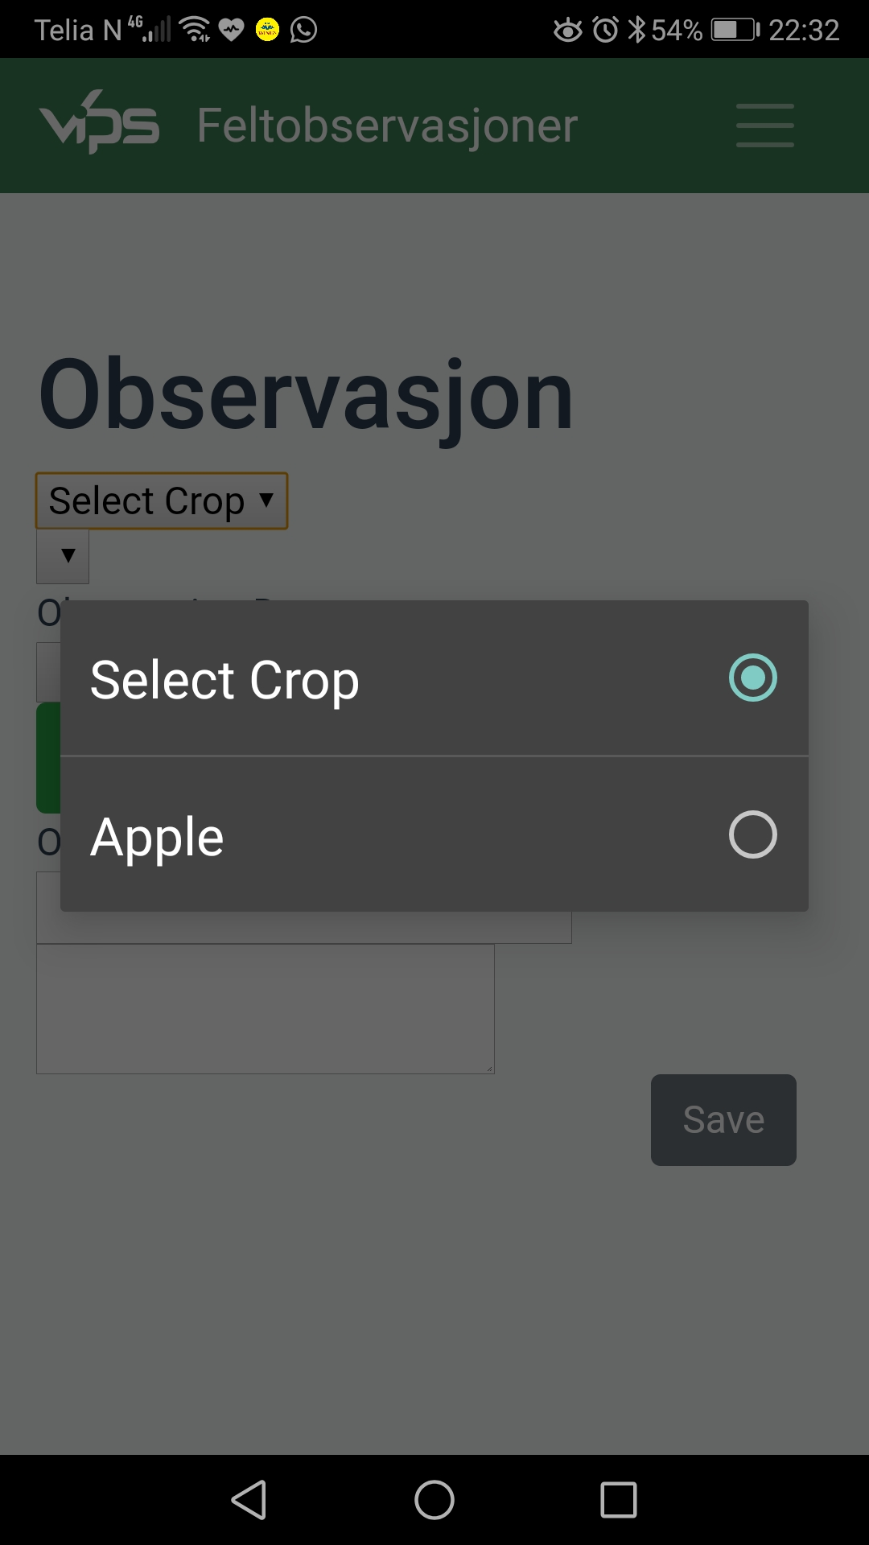
Crop
Clicking on Select Crop drop down will open a popup window with list of crops.

The list of crops actually comes from list of Crop category selected earlier.

Previous screen Fruit selected as crop category. Therefore in new observation available crops are within that crop category. In this case it is Apple.

Please click the available choice of crop
Select Crop

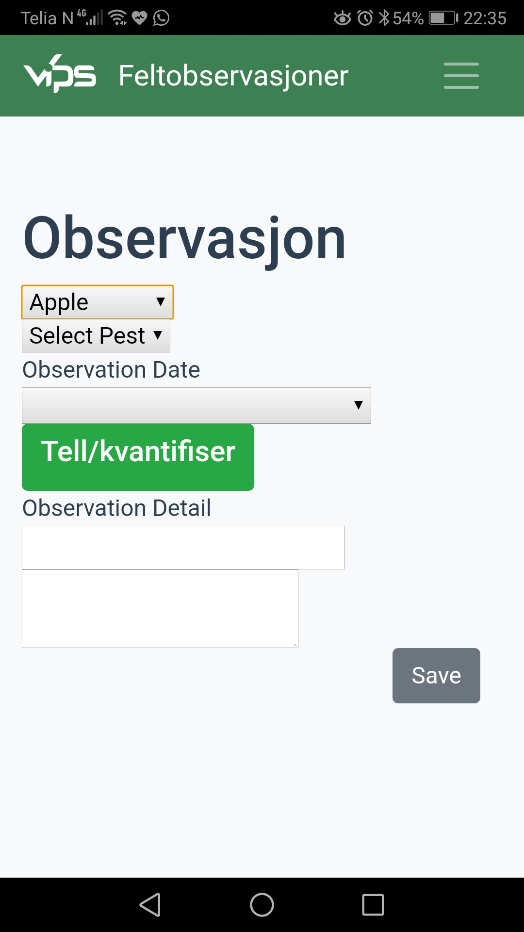
Select Pest

After successful selection of crop, a dropdown list for Select Pest will be visible.

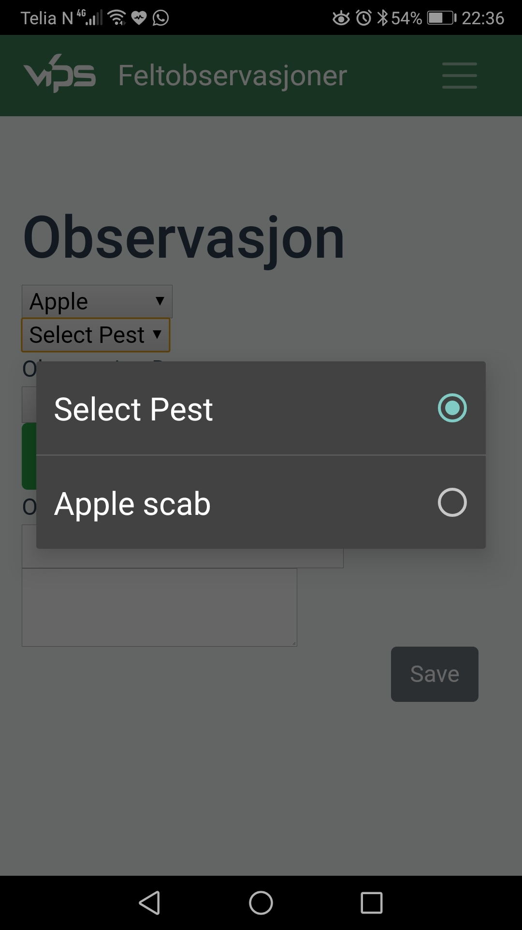

Pest
Select Pest
Based upon crop a list of pest might be available after click the drop down for Select Pest.

Please don’t be surprised if you couldn’t able to see any pest of a particular crop. Sometime some crop are not recorded with attached pest/s.

Click on choice of available from list of pest

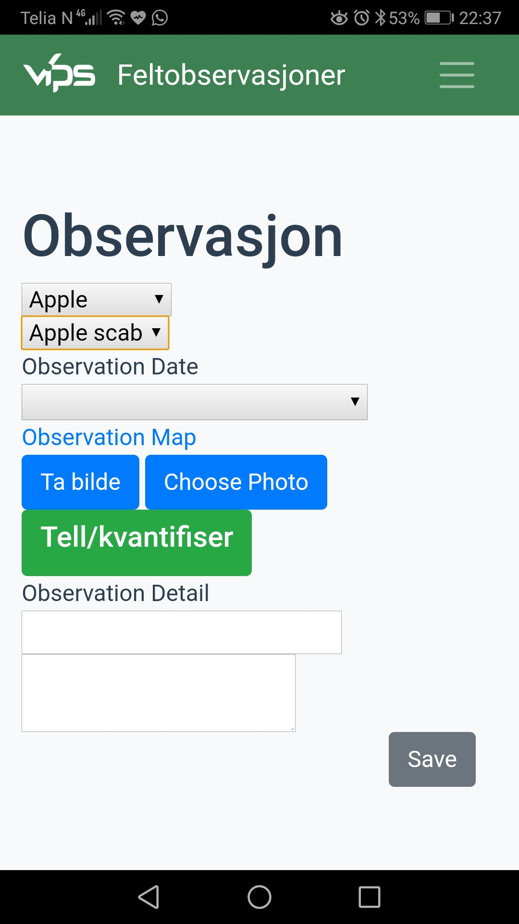
After crop and related pest selected, it’s time to record Observation Date.

Please select Observation Date
Observation Date

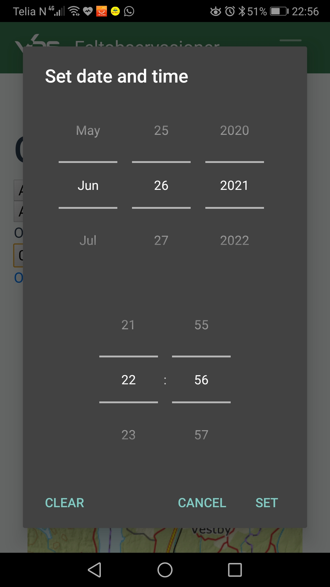
Observation Date

When you click Observation Date dropdown, a popup window for Set date and time will be visible.

Normally it shows current date and time. You can browse other date and time too.

When done click SET button.

You can browse
Date and time.
Click SET to save
Selected date

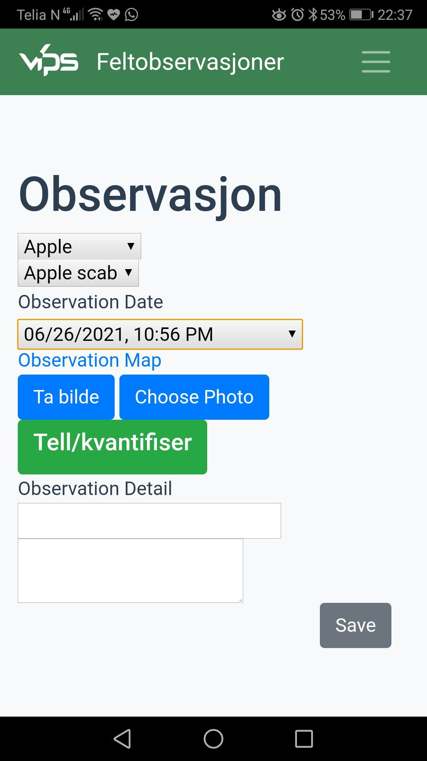
Now Observation Date will be visible.

Now it’s time to set the location.

Please click Observation Map
Observation Map

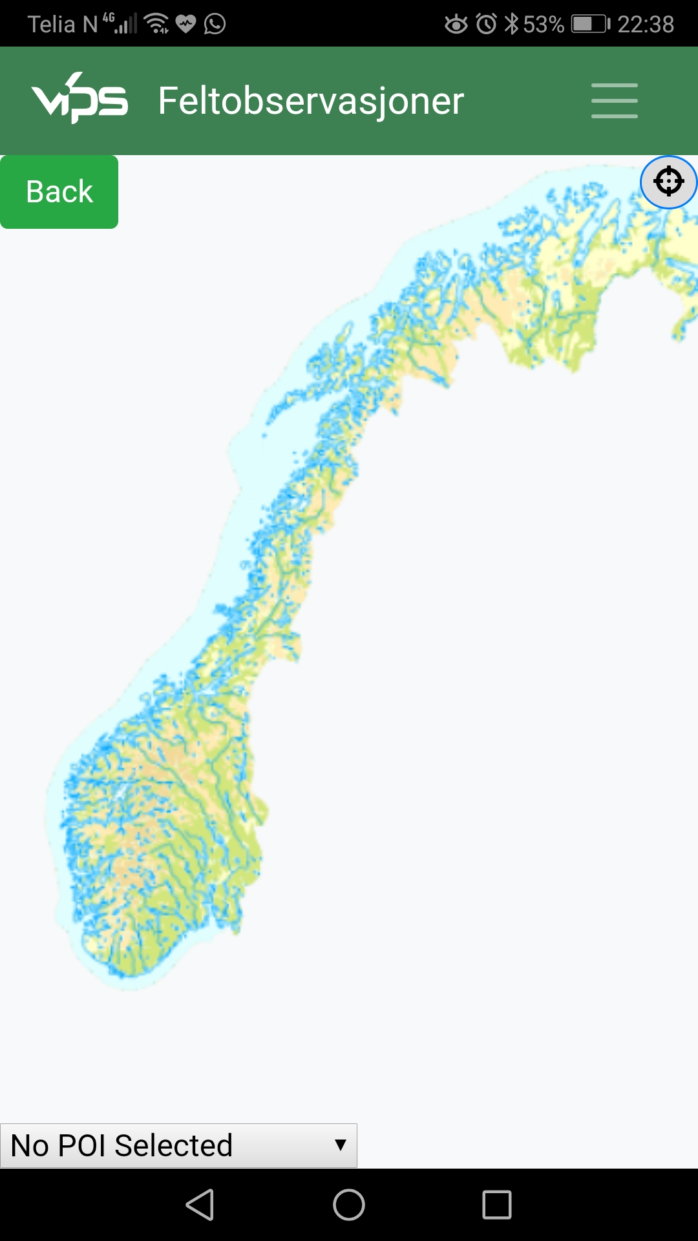
Observation Map
Position button
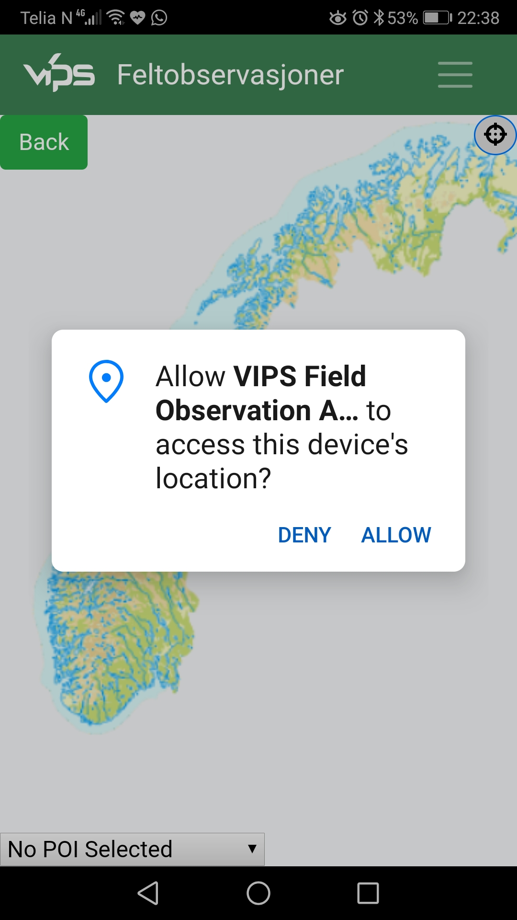
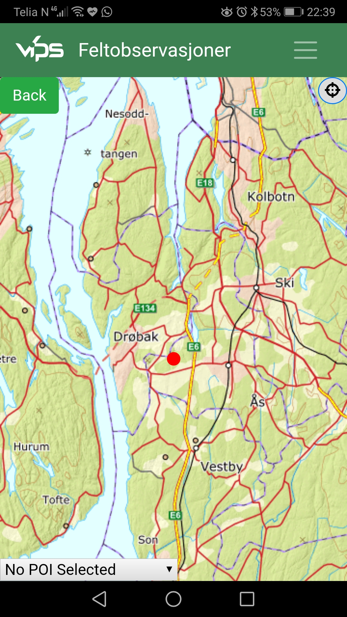
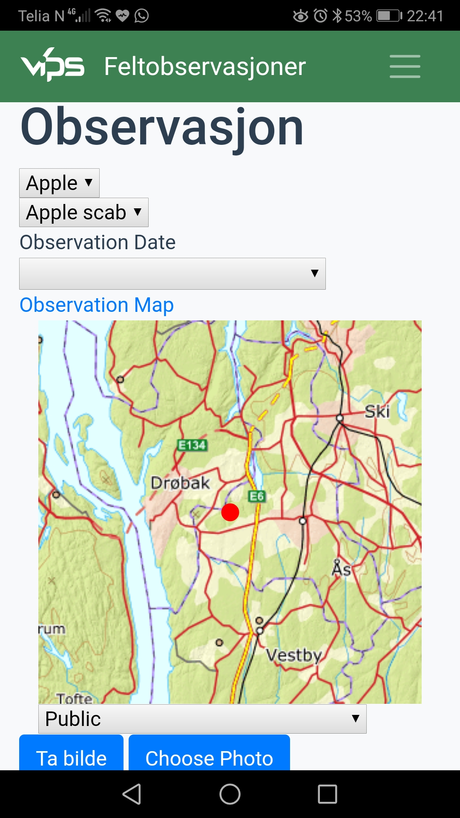
Click on Observation Map link bring a new window which shows Norway Map.

Top left of Norway map is a Back button in green color.
Where as in top right there is a black circular button is there.

That black circular button is position button, which will show user’s present position.

User need to give consent/permission to allow the mobile application to access the device’s location to use the in build GPS system.

Once permission allowed, user’s current location displayed on the map.

However user is free to choose other location by using his finger and tap to fix the location.
Zoom using two fingers possible and permitted.

To get back to ongoing observation, please click the back button.

In Observasjon screen user selected map will be visible.

Note: Map here is not editable. To edit you need to click Observation Map link again.

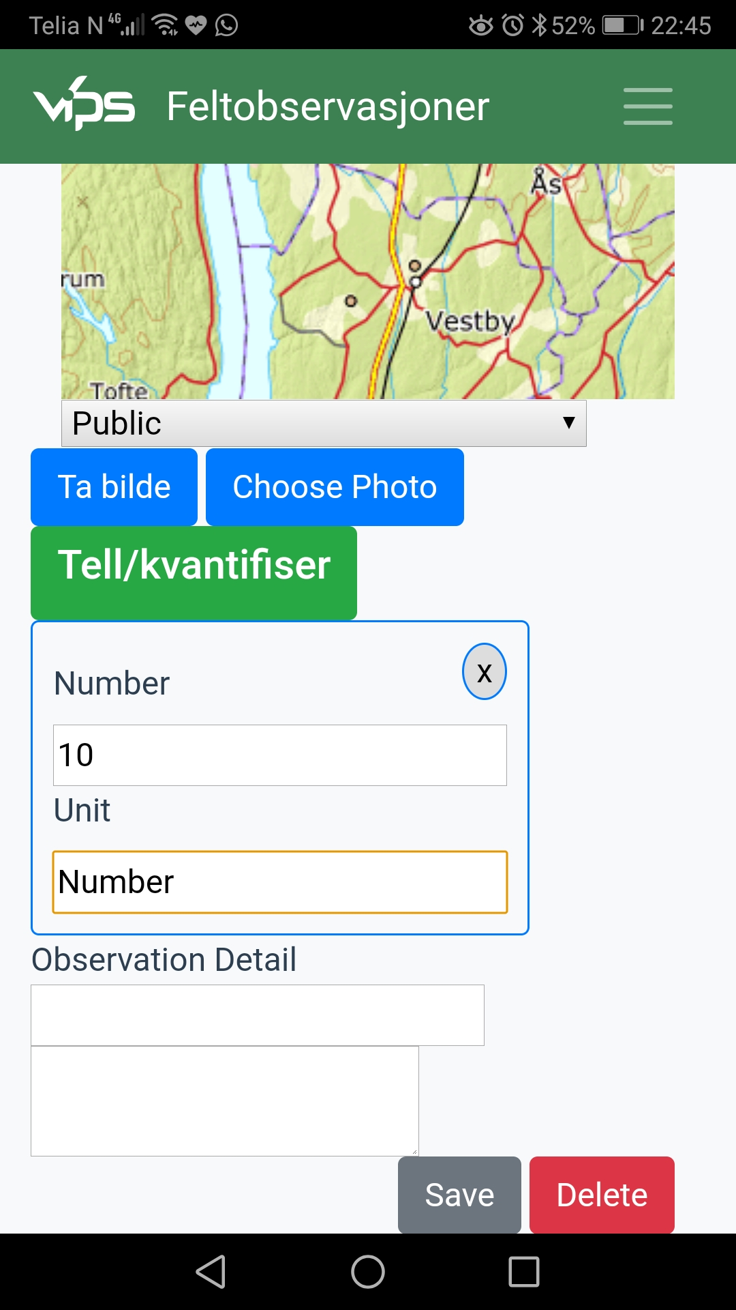
Quantification
For dynamic quantification please click the green button (Tell/Kvantifiser). After filling the form user can close it by clicking X button.

This quantification is not mandatory, therefore user can skip it if not required.

Open
Quantification form

Close

Save
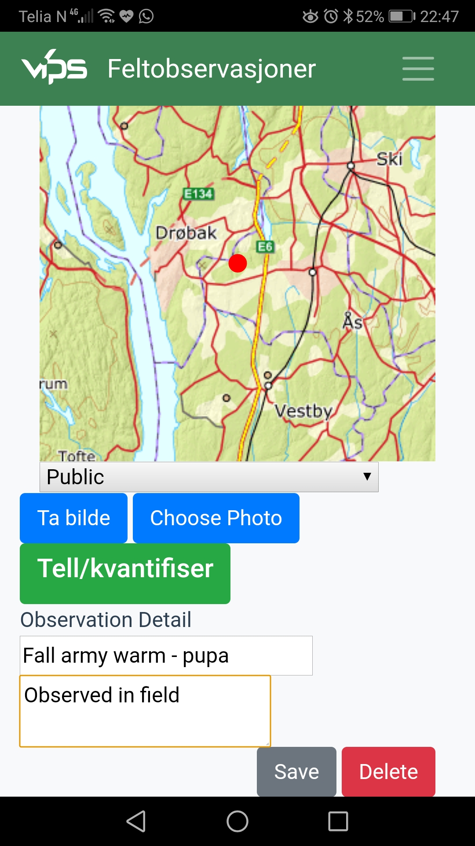
User now can fee Observation Detail.

It’s now possible to save the form.

Note :
User can take the photo at this stage or before. But I would like to request to hold it and don’t do it now unless sync with VIPS Logic server. In this way this observation will be mapped with server and latter taken any image will be properly mapped.

Very soon we will do our photo beautiful photo session. Please wait till then.

Please click Save button.

Observation
Detail

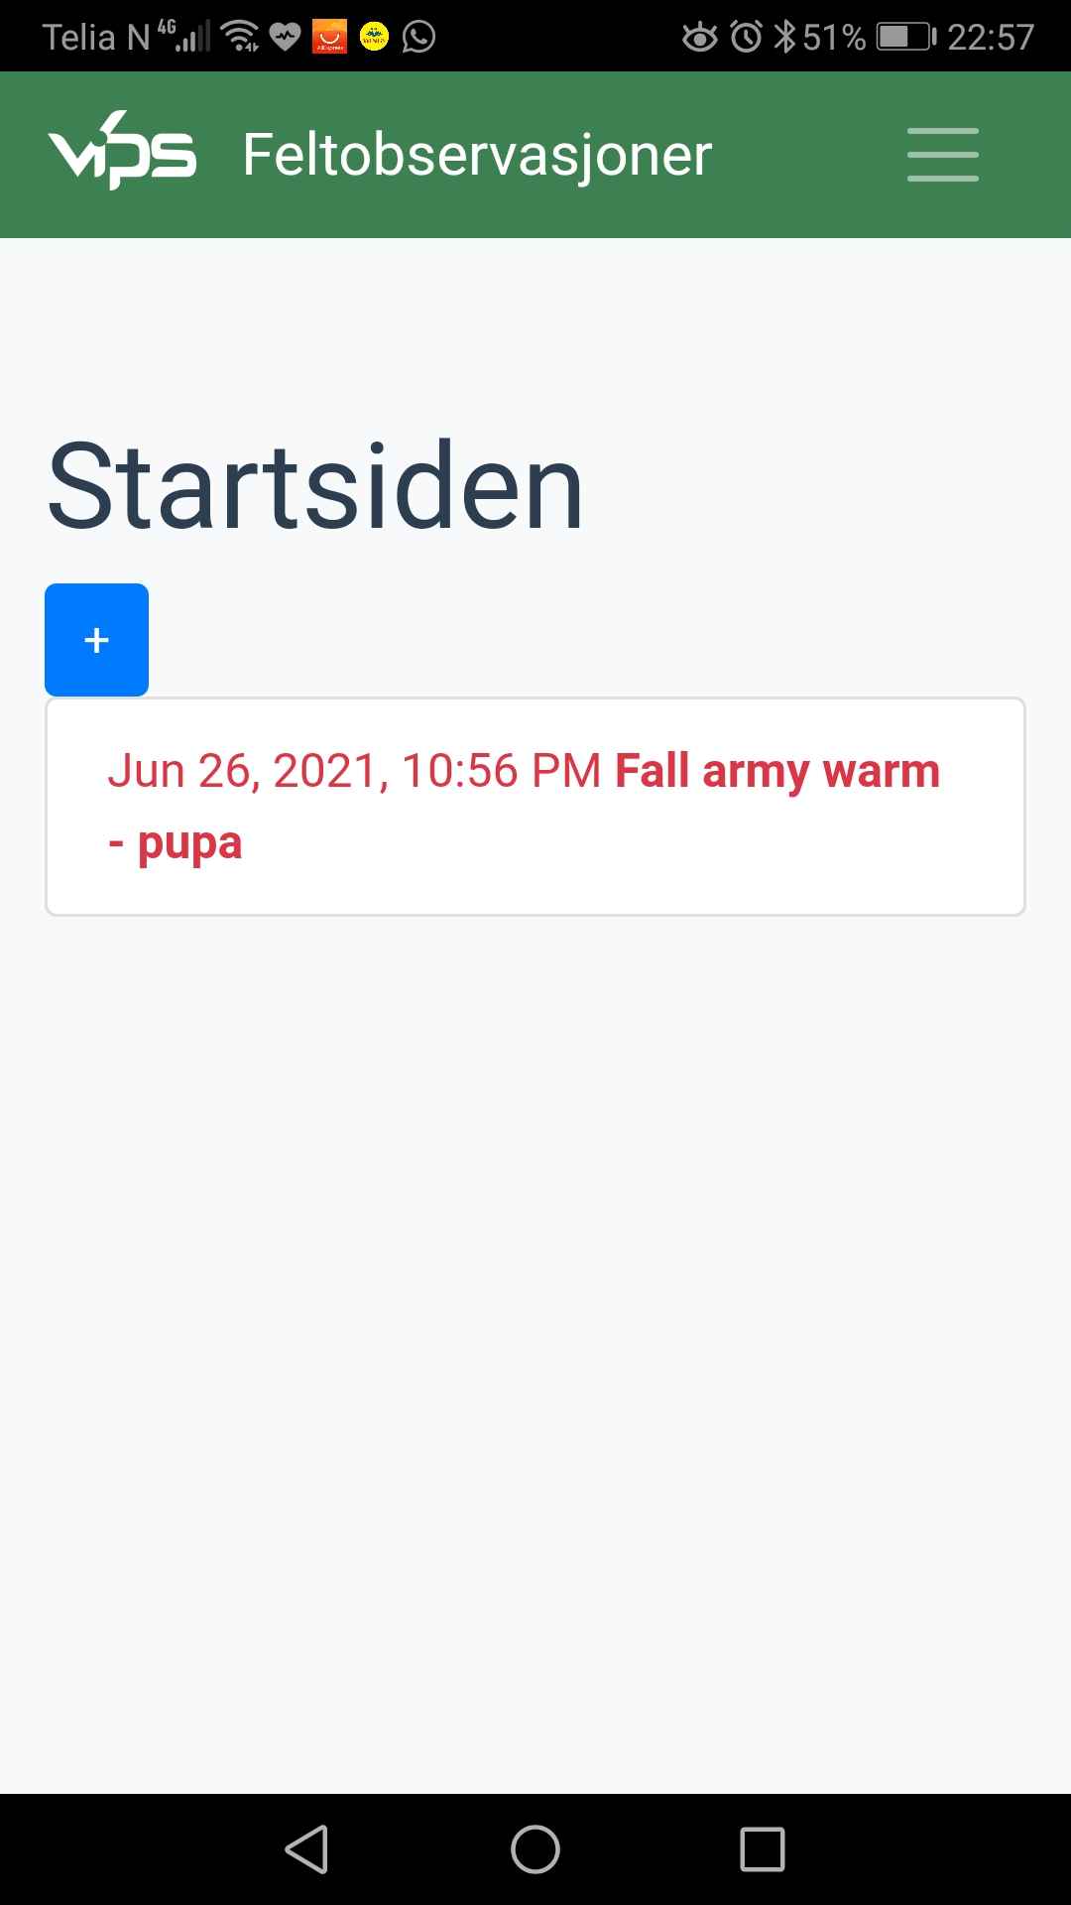
New Local Observations
When a new observation created in mobile application (i.e. not in VIPS Logic Server), and saved, listing shows in red color.

1. Listing in red color indicates it’s new locally
created and still not sync with VIPS Logic
Server.

At this stage if you want to see what happened to the VIPS Logic server, will find no as such related records there still.

2. To confirm please login to
http://logic.testvips.nibio.no with your test
VIPS Logic user id and password

3. From Admin menu select Observation

4. Select range of dates to cover the newly
created observations. And click the filter
button. Hopefully, you will not find any
related record still their.

5. To sync with VIPS Logic Server, we need to
click the Sync button in Mobile application’s
settings (Innstillinger).in menu.

Please click Menu to reach settings (Innstillinger) in mobile application

5
Menu

New Observation

1

2
3
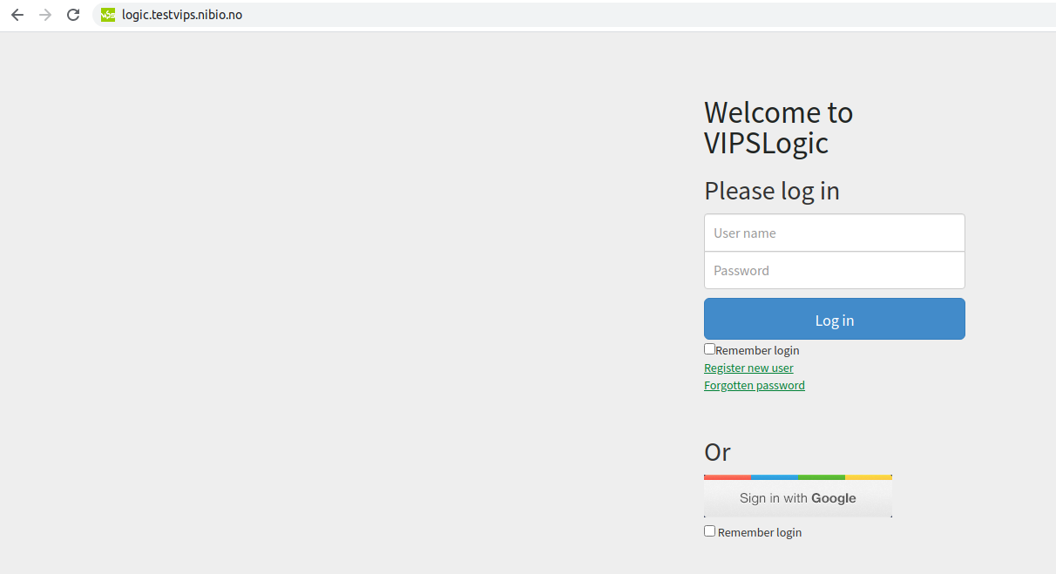
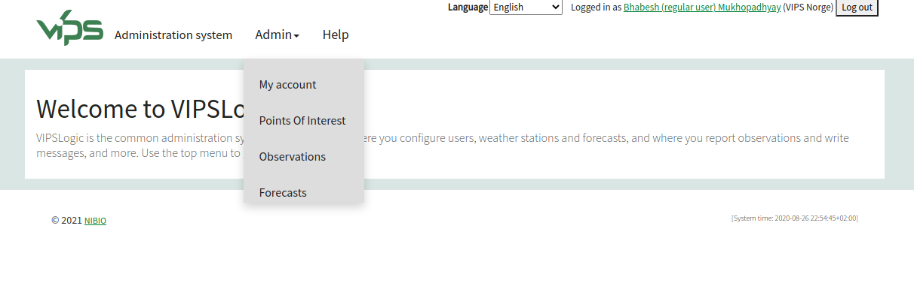

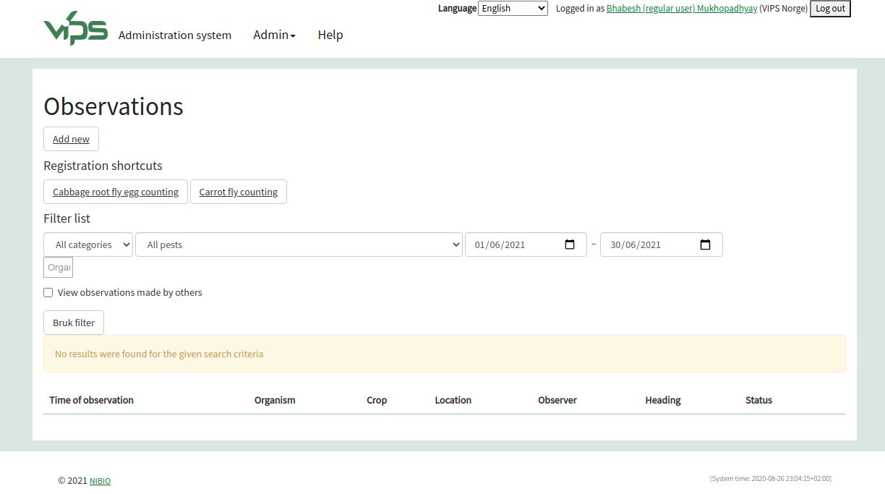

4
Filter button

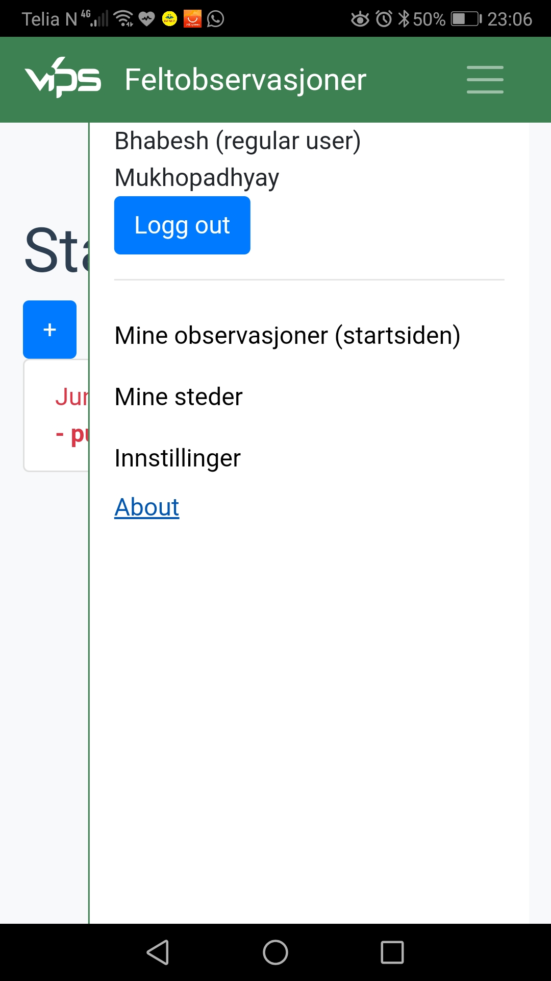
Sync (Synchronize)
Observation List
Sync or Synchronization is the process to transfer the data two way between server and mobile application such a way that both the places should have equal amount of data.

It helps VIPS Logic server to get the observation data and analyze on it, other hand it helps user to get any data modified/created in server to be available in mobile app.

At present Sync is a user driven process. In near future, it will be full automatic without user’s any intervention.

1. Therefore to activate sync user needs to click settings (Innstillinger)

2. You will find Sync button under crop category

3. Please click the Sync button. It’s back ground will change to Sync . It means button clicks and background process start working for syncing data.

4. Please click Observation List (Feltobservasjoner) to back to see the list of your observations.
4

Settings
(Innstillinger)

1

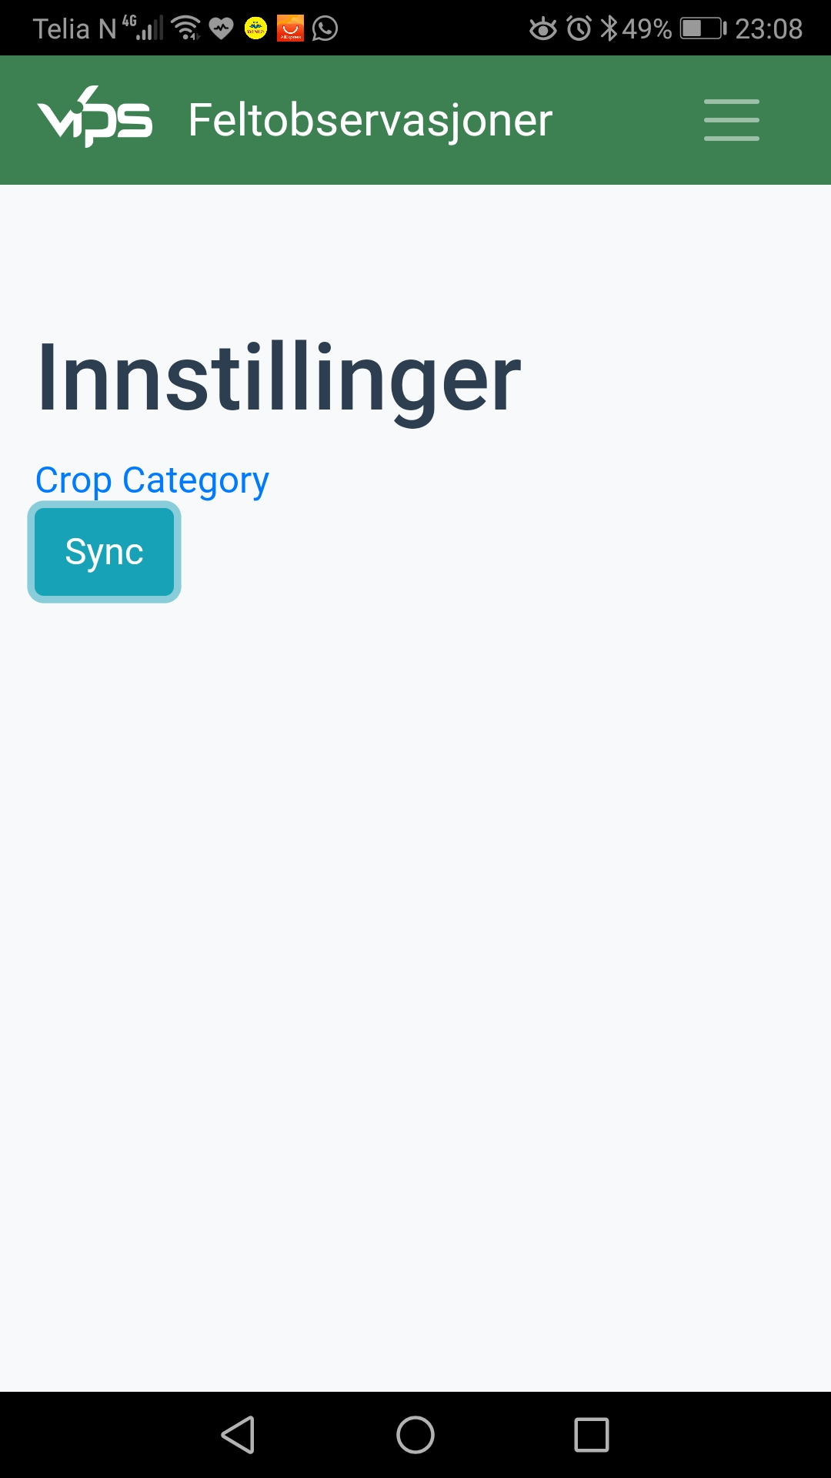
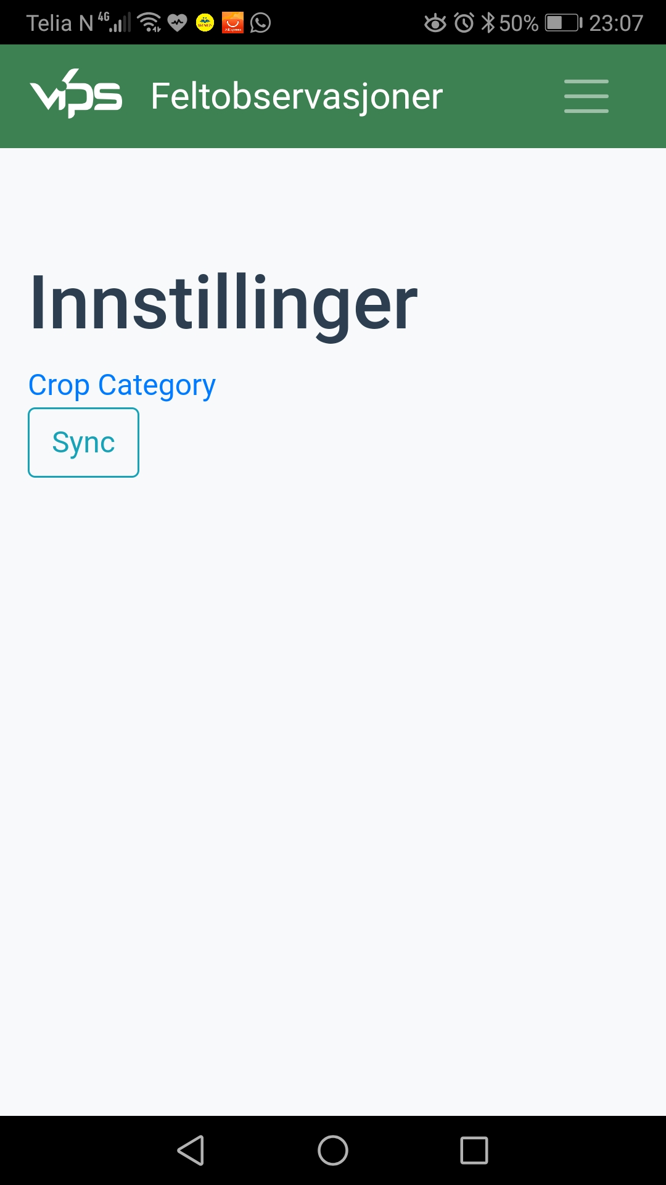
Sync

2
3

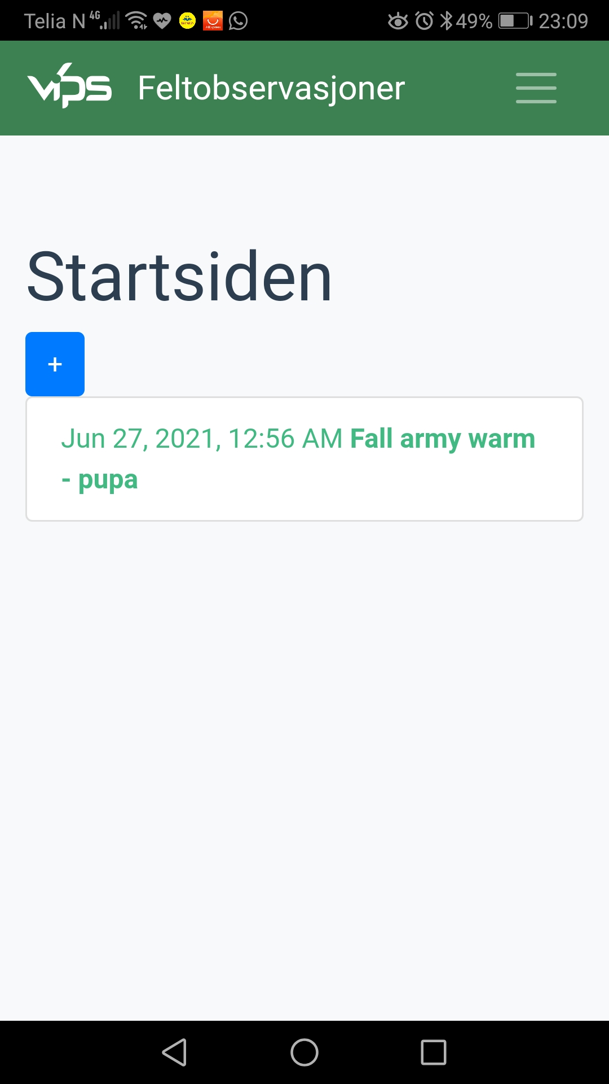
Existing Observation
1. Now you can see your observation which was color red now turned to green.

Green color indicates, your observation successfully synced or mapped with VIPS Logic server.

To confirm, please login to http://logic.testvips.nibio.no/
From Admin menu select Observations in Filter list choose range of dates to cover your observation taken . Click Filter (Bruk filter) .

2. You will find your observations here. Please click Edit button to details of the Observation.

3. You will see your detail observation. Including position in map, quantitative data, and your observation details.

You can modify your data here and using sync in mobile application your modification will be available in mobile application too. I suggest, not to do this now. First we need to see more features in mobile application.

1

2
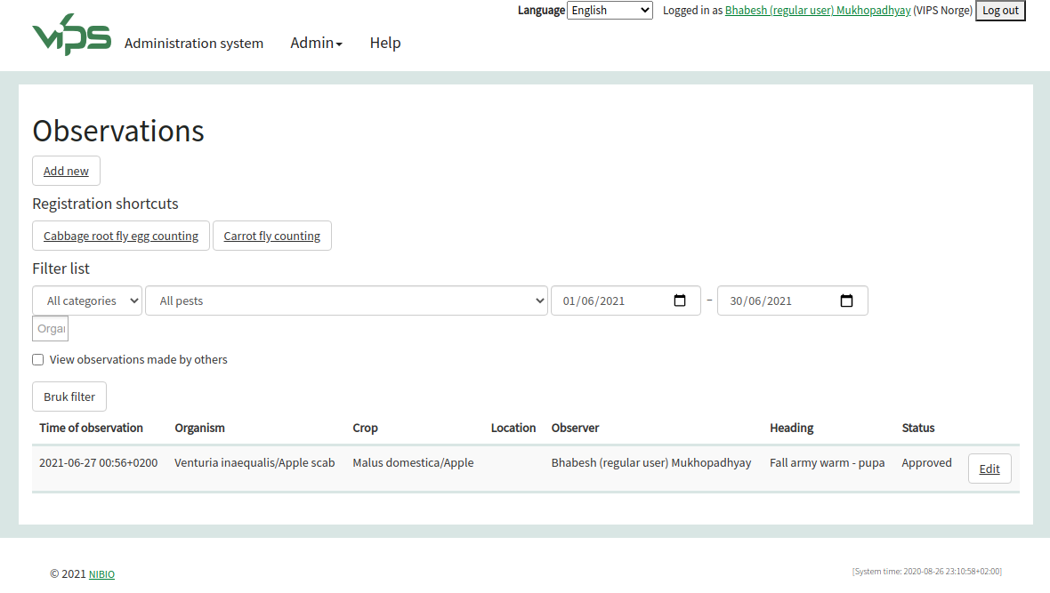
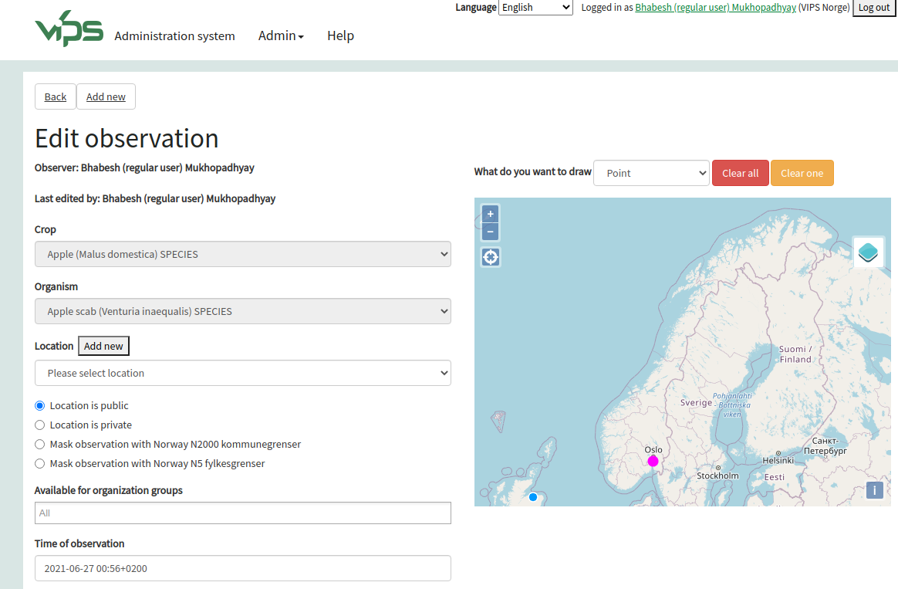

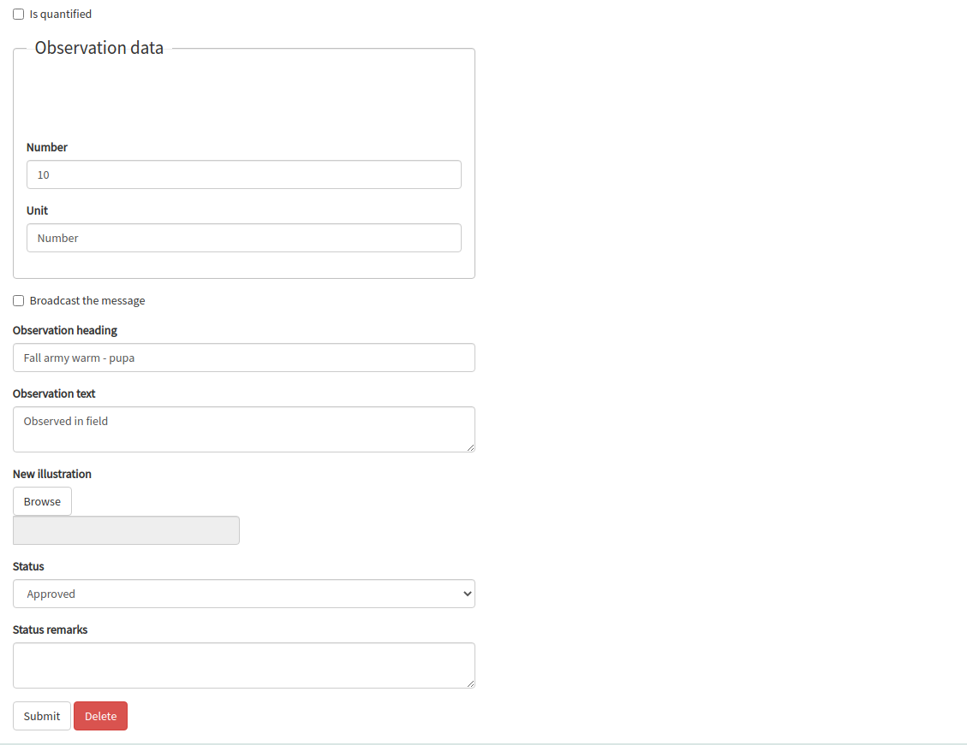

3

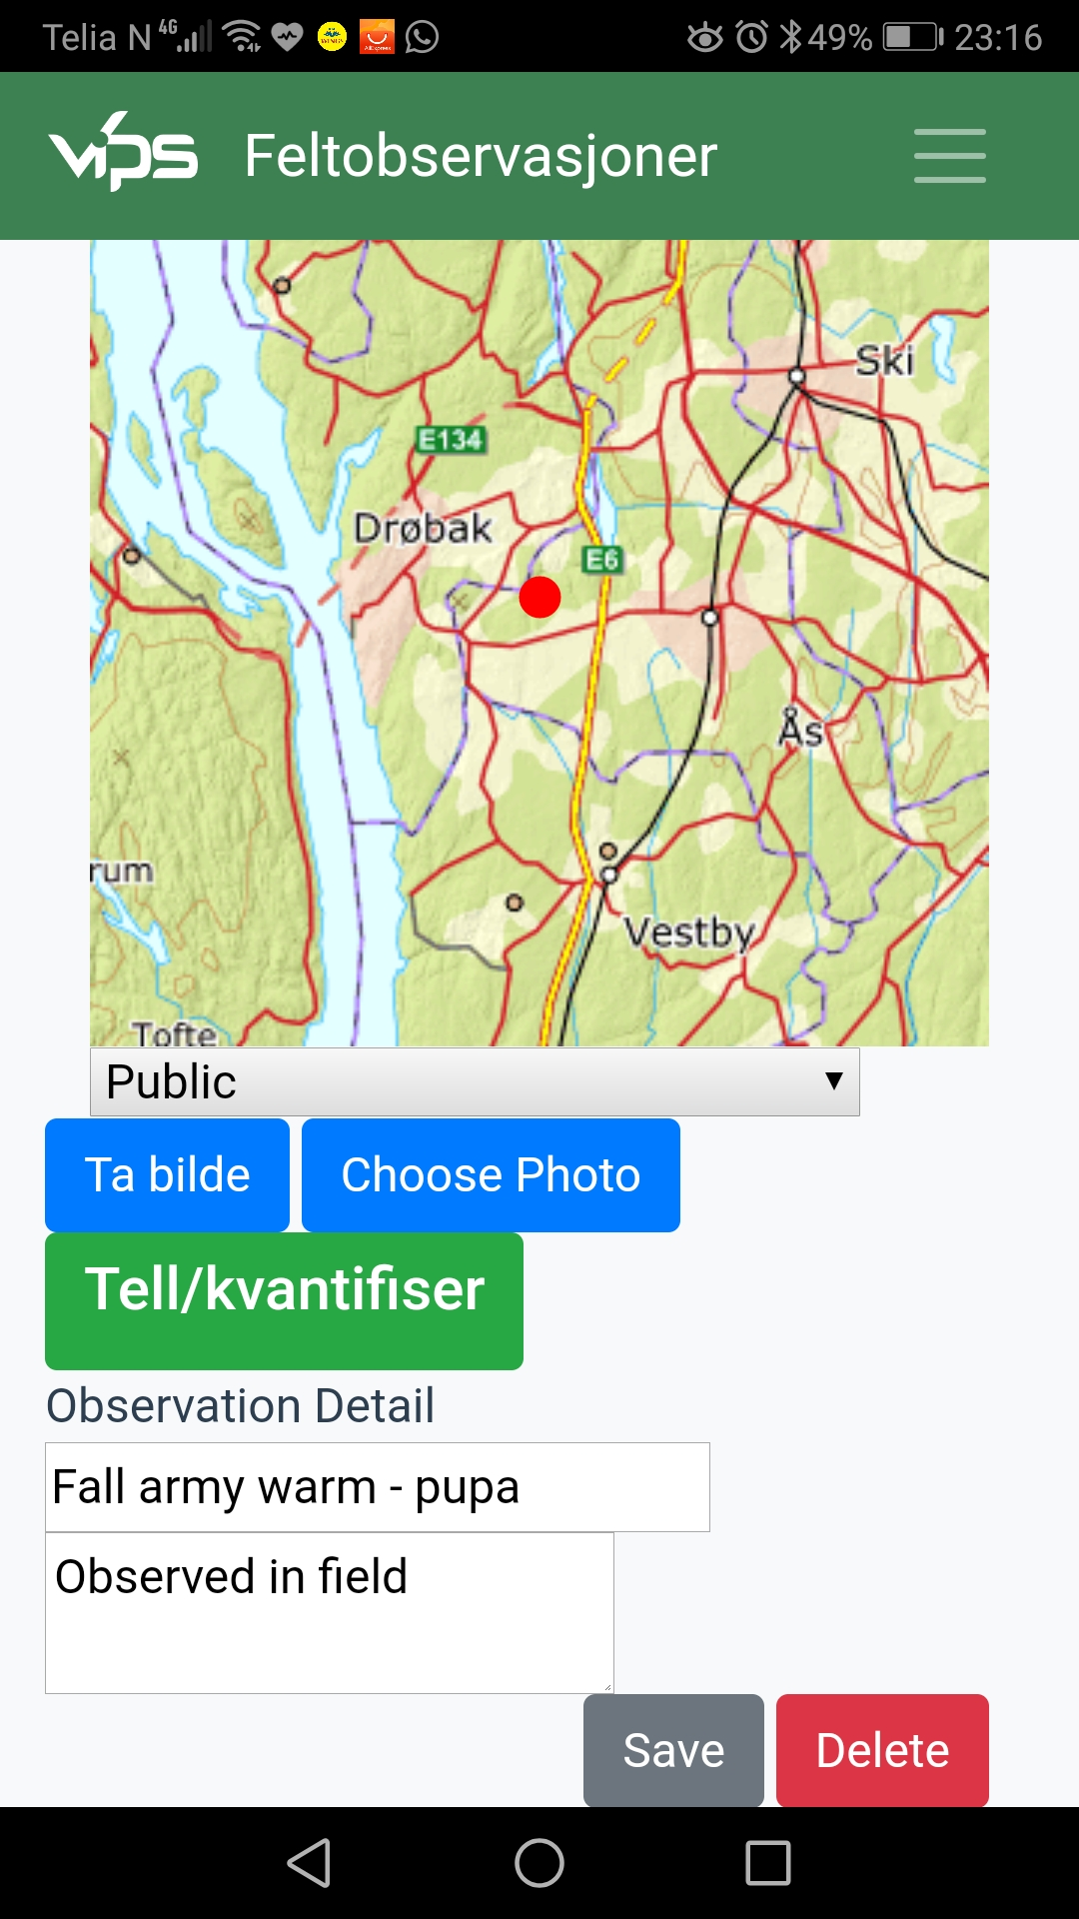
Capturing Images
Images are interesting and might consider a important part of observation.

In this section we will find out options and way to capture or include images through Observation mobile application and contribute to VIPS Logic server.

1. It’s possible to take photo directly from phone camera for observation app.

2. It’s also possible to include previously captured stored images in your phone storage.

To take photo/image using built in system, please click
Ta bilde button of any open observation of your choice.

2

Choose
Picture
From
Phone’s
storage
1

Take
Picture

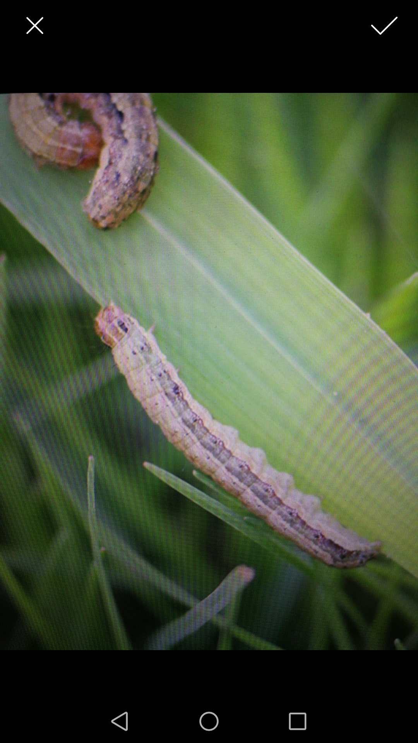
You can use front or back any one of your camera. After taking the picture, you will find a check mark on top right and X mark on your top left. X mark used for canceling the selection where as you can save the image using the check mark on your right.

To save the picture please click the check mark on top right

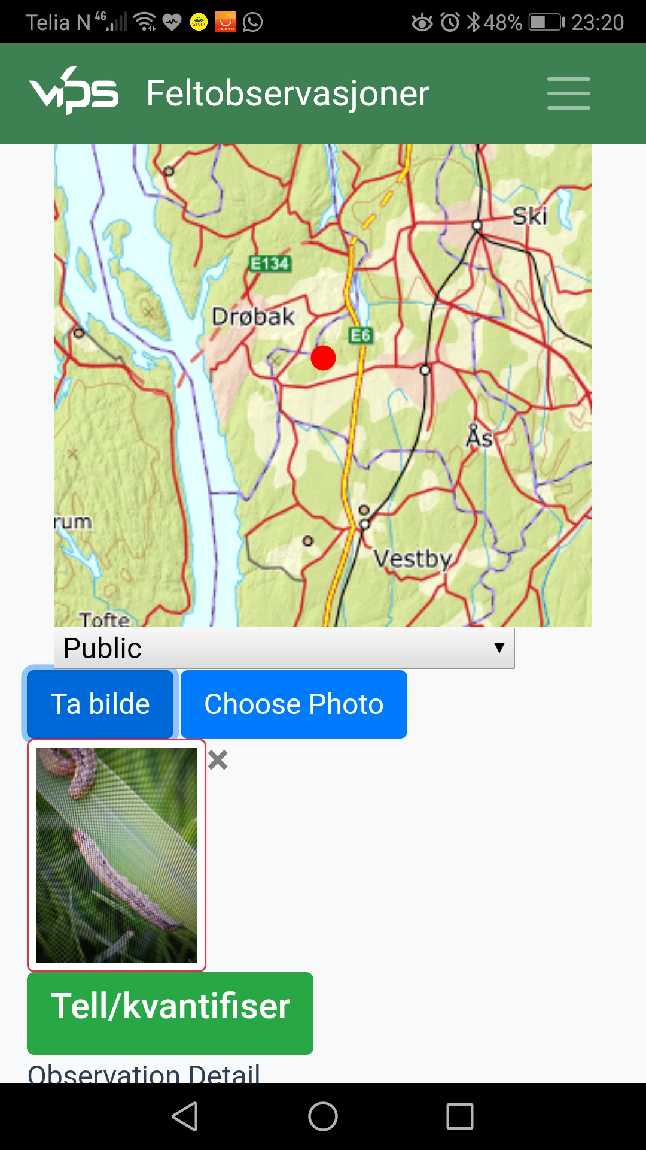
Save/Delete Image
The moment you click the check mark on top right after capturing image, it automatically save into your mobile phone and mapped with a related specific observation.
After saving the screen will back automatically to Observation with thumbnail of that same image.

But it’s still advisable to click save button of the observation to let the system know for future Sync process.

You can click the image to see enlarged view.

To delete or remove an image, user need to click the X button on top right corner of every image.

To remove/
Delete,
Click X

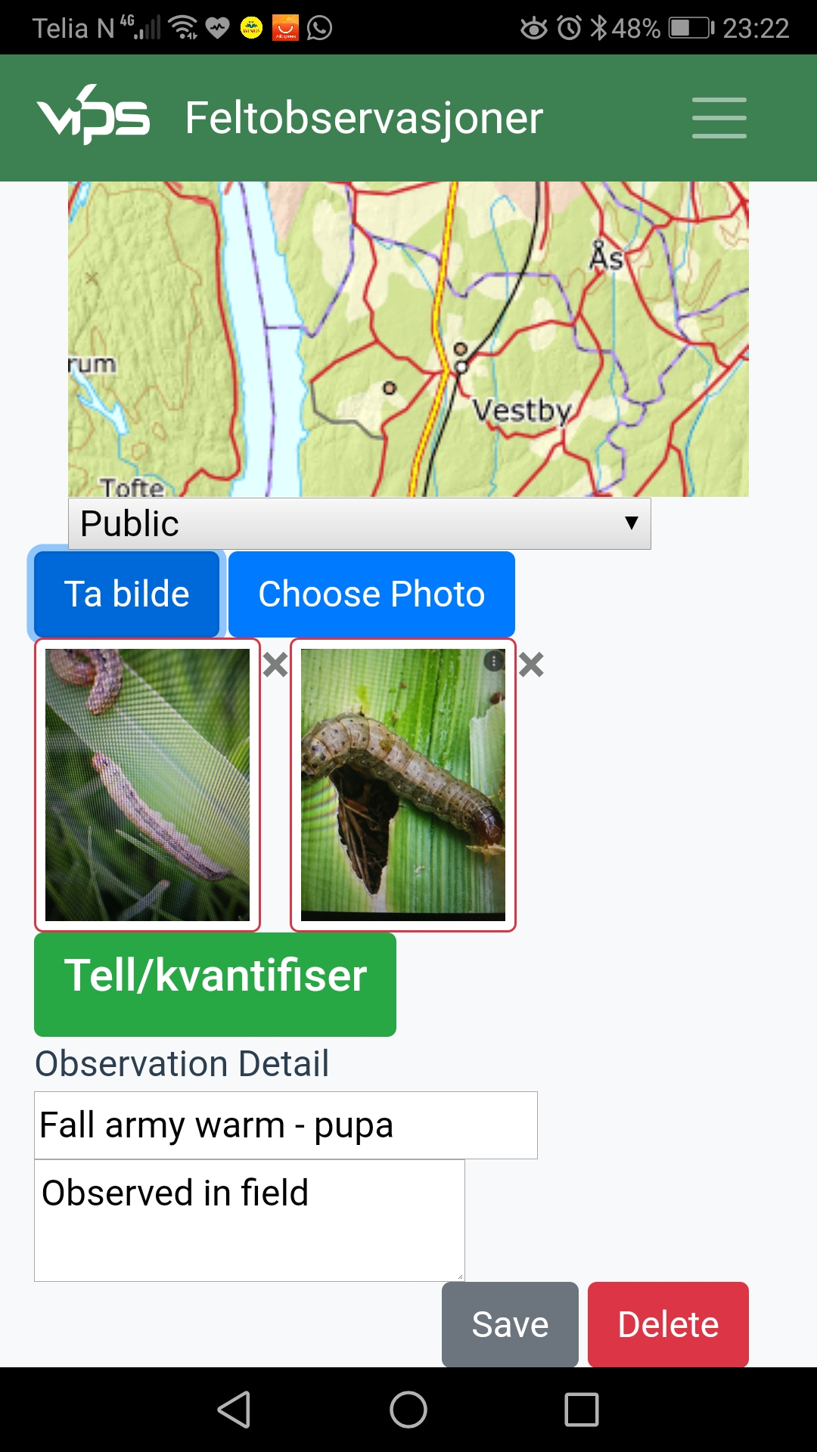
Multiple images can be captured.

Any newly image captured will be with red boundary.
Any existing image will be with blue boundary.

But the moment a observation sync with VIPS Logic server, there will be no color boundary.

Now it’s time to sync those images captured with VIPS logic server.

To achieve this you are requested to click save button.

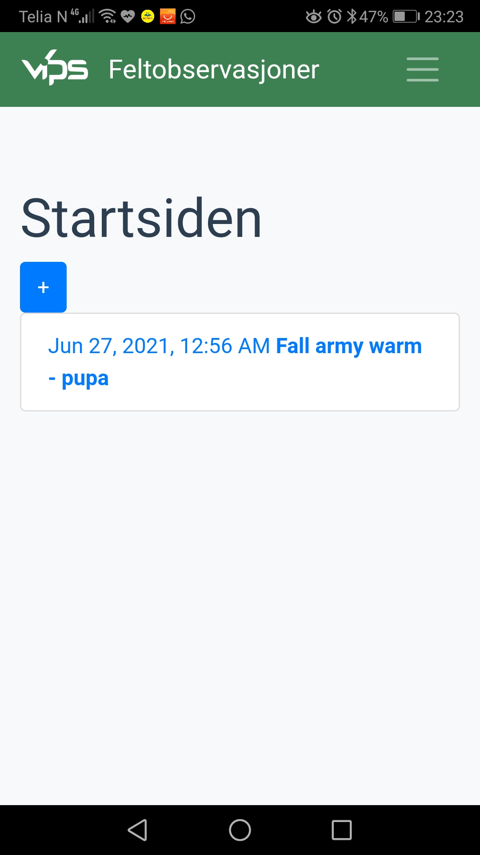
Updated Local Observations
After saving an observation, Observation list comes in front.

Any existing observation will turned blue after edited locally.

This blue color indicates this Observation exists in VIPS Logic server but need to sync again to push it’s local changes (e.g. adding/deleting images, editing data etc) with VIPS Logic server.

Therefore to achieve this need to sync again.

Please click Menu / Settings (Innstillinger) / Sync to sync/transfer the information.

1

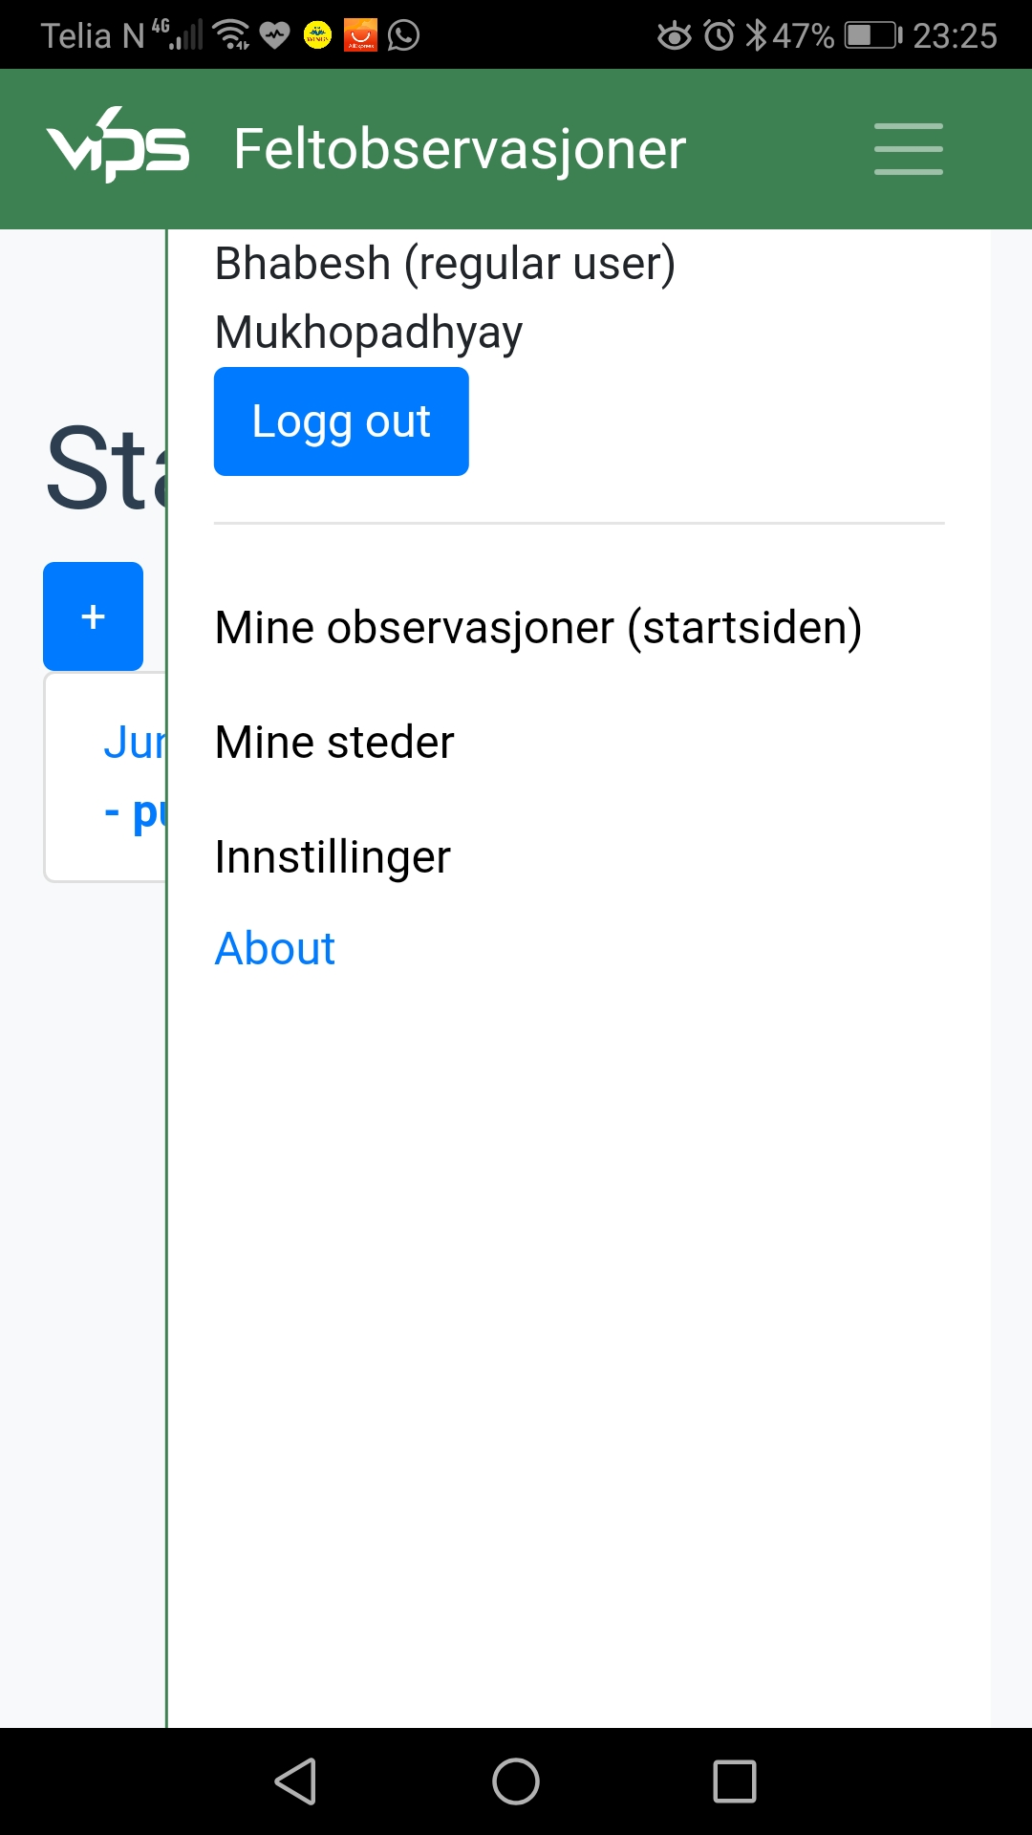
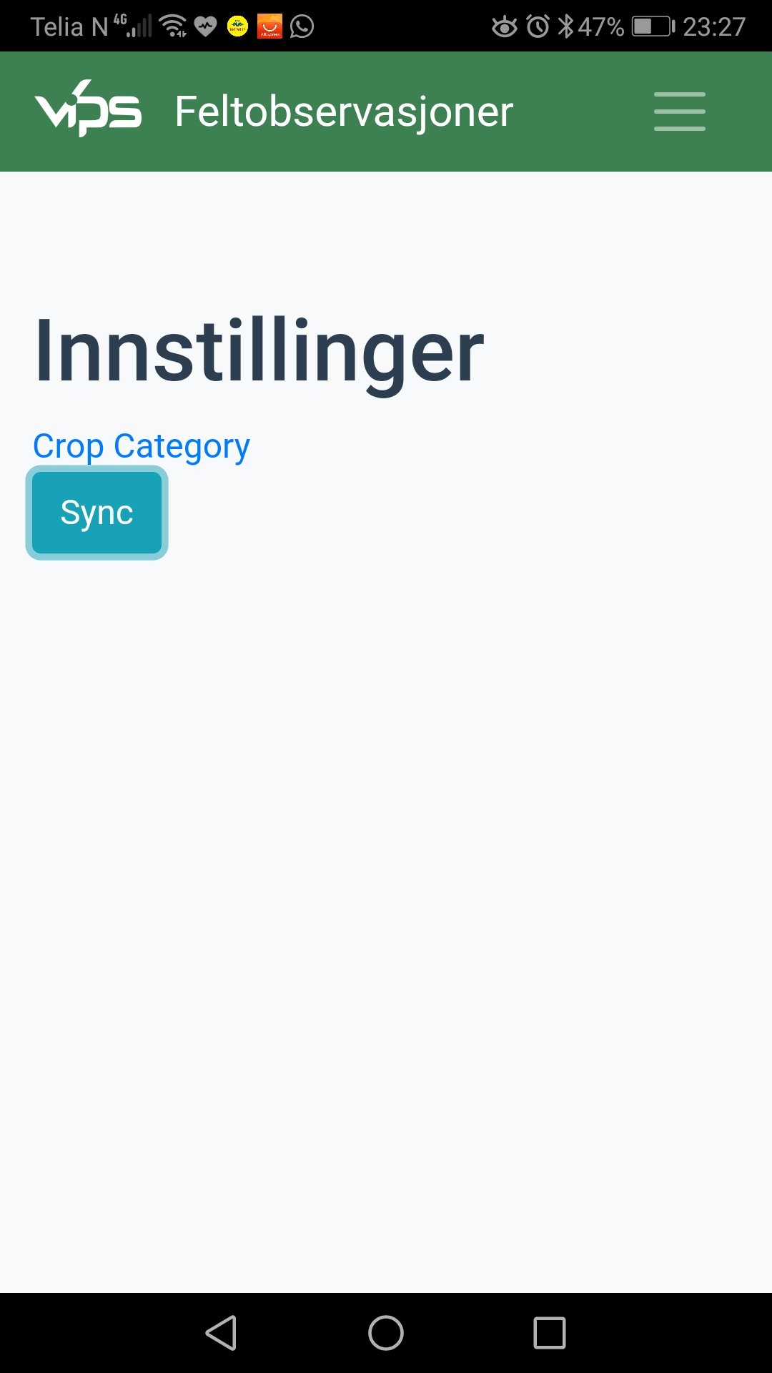
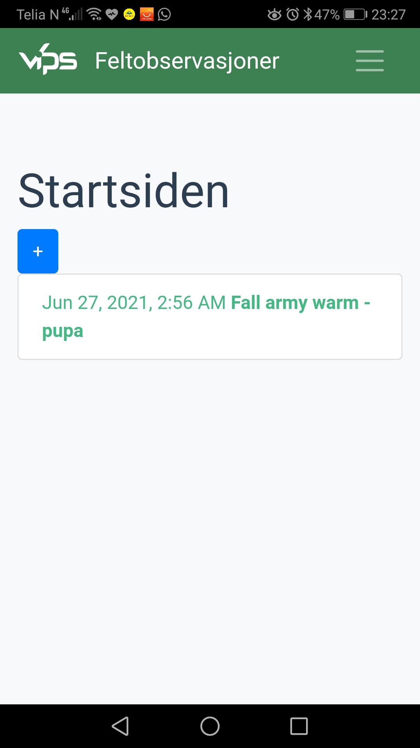
2
3
4
5

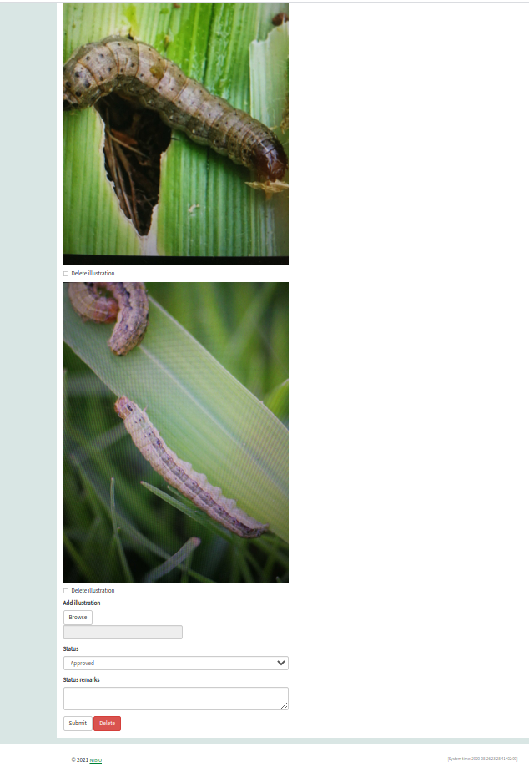
Server update
To confirm sync, please open VIPS Logic test server using your id and password with the following url :

http://logic.testvips.nibio.no

Search your particular existing Observation. Open the observation using edit button and you will find the images what you added in your mobile application are available at your observation in VIPS Logic test server.

Here together we learned functionalities of VIPS Observation mobile application and sync process with VIPS Logic test server.

There are some features are there which are also very interesting. Hope you will explore those features and enjoy the application. Please don’t forget to let us know how you feel it and advise us for area of improvement.

